**Lab 04: Inheritance and Polymorphism**

Link GitHub: https://github.com/Dathazayuki/OOP4-20225701-Tr-nh-Minh-t

Họ và tên: Trịnh Minh Đạt

MSSV: 20025701

1. **Import the existing project into the workspace of Eclipse**

File AimsProjects.zip

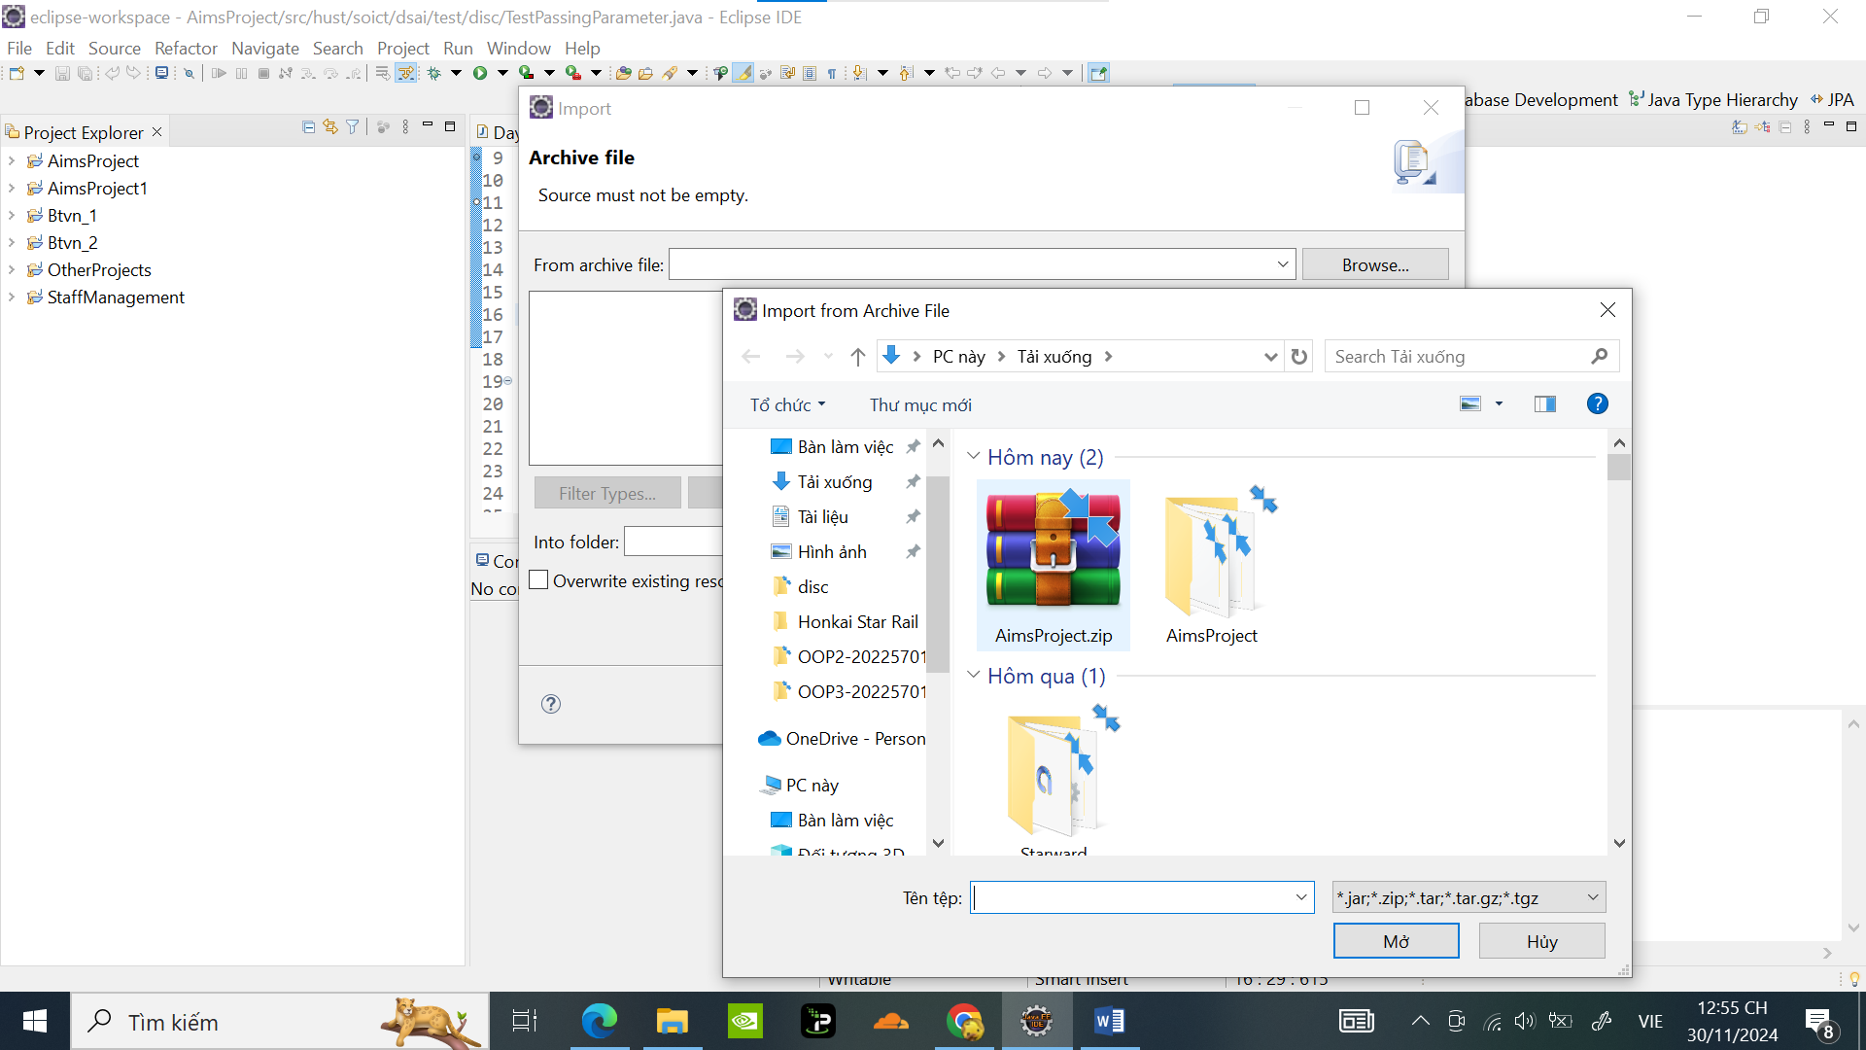

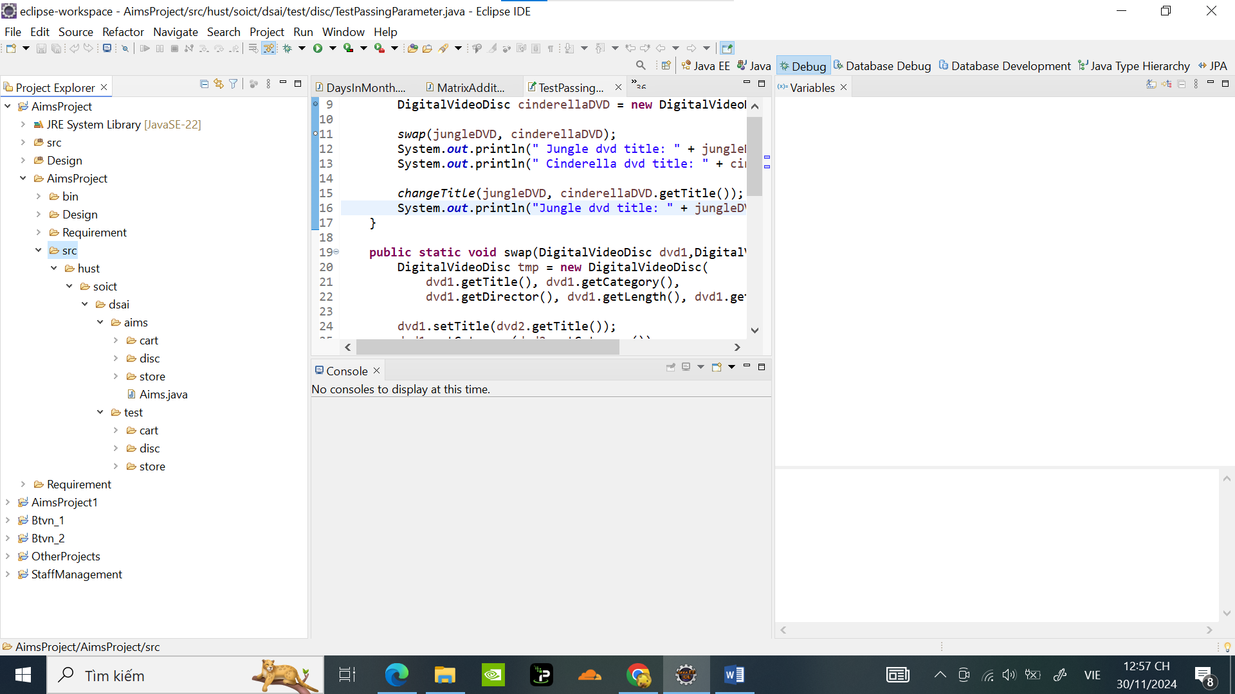

Tạo *topic/aims-project/add-media-class* trên Github

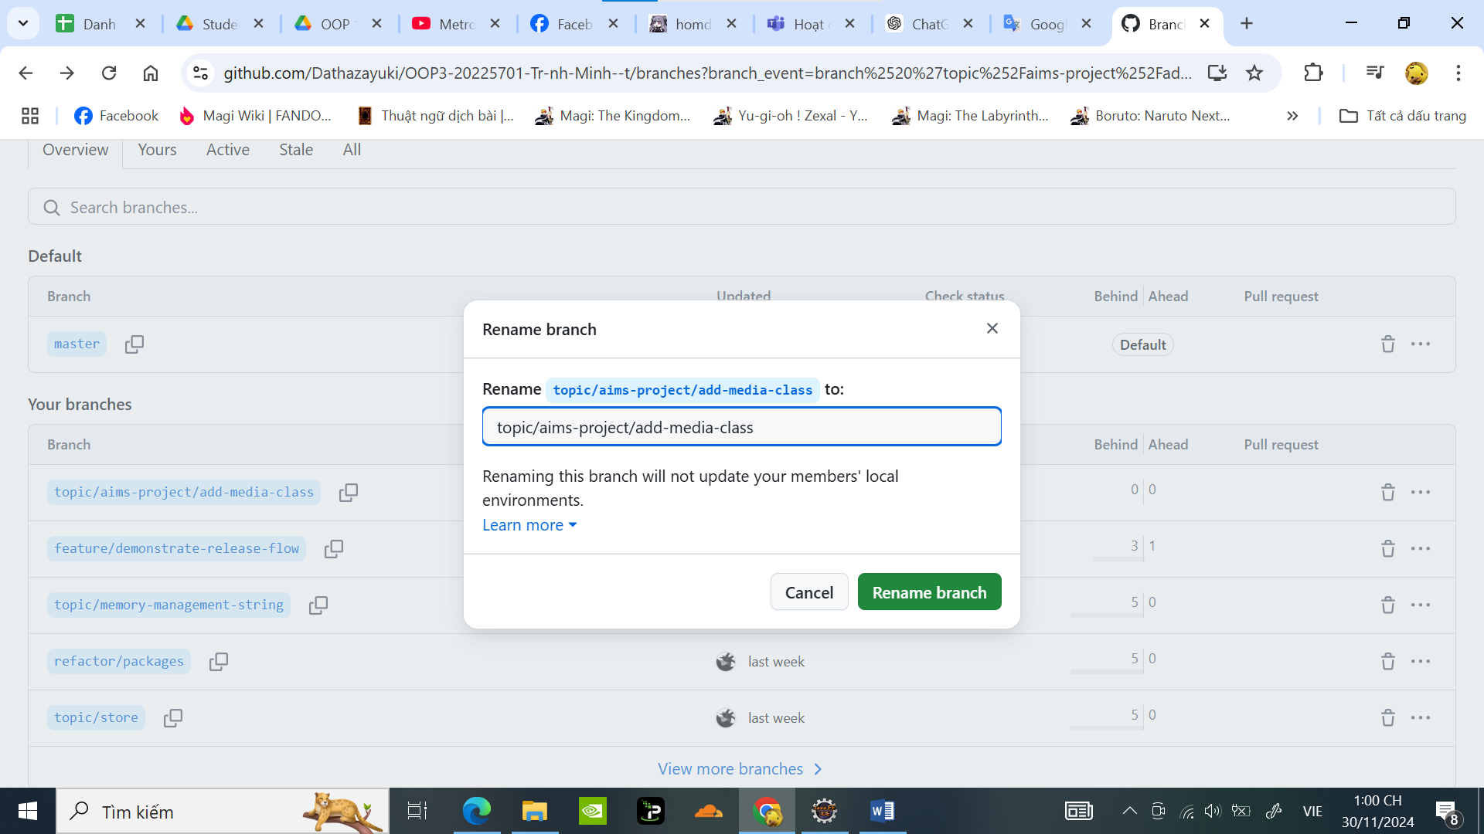

1. **Additional requirements of AIMS**
2. **Creating the Book class**

Code tạo class Book:

**package** hust.soict.dsai.aims.media;

**import** java.util.ArrayList;

**import** java.util.List;

**public** **class** Book {

**private** **int** id;

**private** String title;

**private** String category;

**private** **float** cost;

**private** List<String> authors = **new** ArrayList<String>();

**public** Book(**int** id, String title, String category, **float** cost , List<String> authors ) {

// **TODO** Auto-generated constructor stub

**this**.title = title;

**this**.category = category;

**this**.id = id;

**this**.authors = authors;

**this**.cost = cost;

}

**public** **void** setAuthors(List<String> authors) {

**this**.authors = authors;

}

**public** **void** addAuthor(String authorName) {

**if** (!authors.contains(authorName)) { // Check if the author is not already in the list

authors.add(authorName); // Add the author if not present

System.***out***.println(authorName + " has been added.");

} **else** {

System.***out***.println(authorName + " is already in the authors list.");

}

}

// Method to remove an author from the authors list

**public** **void** removeAuthor(String authorName) {

**if** (authors.contains(authorName)) { // Check if the author is in the list

authors.remove(authorName); // Remove the author

System.***out***.println(authorName + " has been removed.");

} **else** {

System.***out***.println(authorName + " is not in the authors list.");

}

}

// Utility method to display all authors (for testing purposes)

**public** String getAuthorsAsString() {

**return** String.*join*(", ", authors);

}

**public** **int** getId() {

**return** id;

}

**public** **void** setId(**int** id) {

**this**.id = id;

}

**public** String getTitle() {

**return** title;

}

**public** **void** setTitle(String title) {

**this**.title = title;

}

**public** String getCategory() {

**return** category;

}

**public** **void** setCategory(String category) {

**this**.category = category;

}

**public** **float** getCost() {

**return** cost;

}

**public** **void** setCost(**float** cost) {

**this**.cost = cost;

}

}

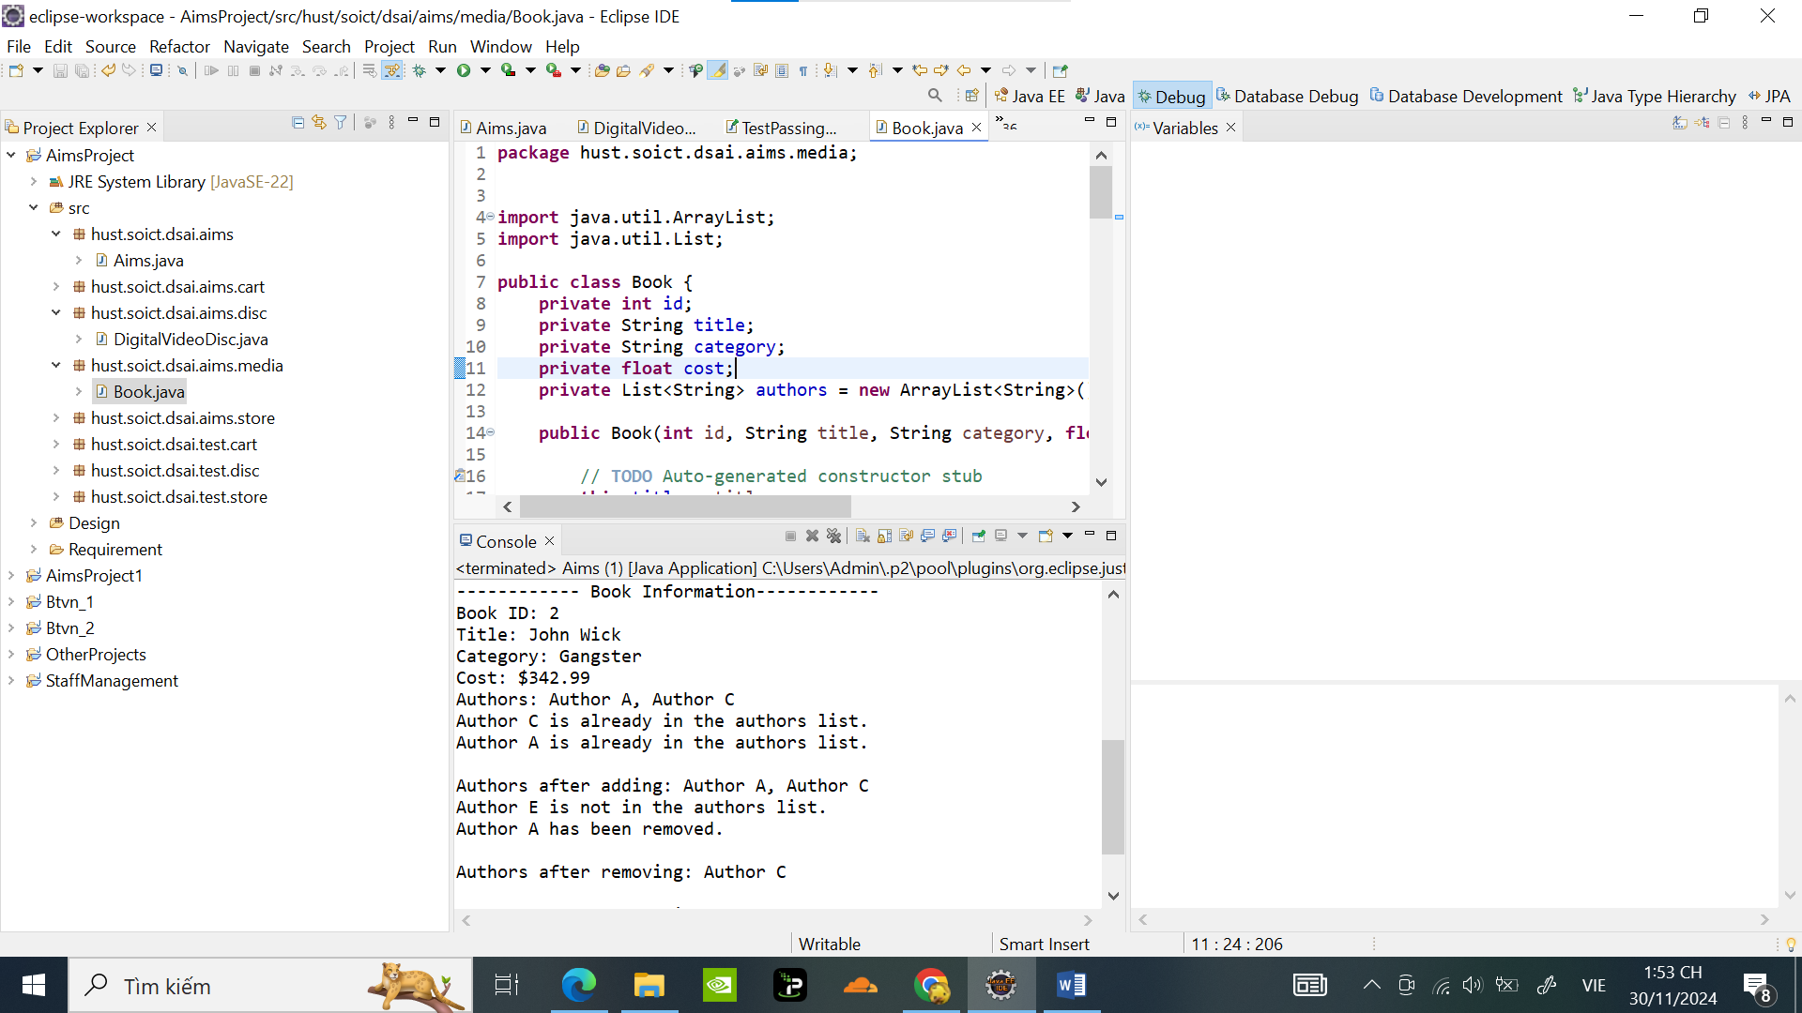

Test thử chương trình với Book1, Book2 in Aims:

**package** hust.soict.dsai.aims;

**import** java.util.ArrayList;

**import** java.util.List;

**import** hust.soict.dsai.aims.media.Book;

**public** **class** Aims {

**public** **static** **void** main(String[] args) {

// Tạo danh sách ban đầu cho authors

List<String> initialAuthors = **new** ArrayList<>();

initialAuthors.add("Author A");

initialAuthors.add("Author B");

// Tạo đối tượng Book

Book book1 = **new** Book(1, "Java Programming", "Education", 39.99f, initialAuthors);

Book book2 = **new** Book(2, "John Wick", "Gangster", 342.99f, initialAuthors);

// Hiển thị thông tin ban đầu của Book

System.***out***.println("------------ Book Information------------");

System.***out***.println("Book ID: " + book1.getId());

System.***out***.println("Title: " + book1.getTitle());

System.***out***.println("Category: " + book1.getCategory());

System.***out***.println("Cost: $" + book1.getCost());

System.***out***.println("Authors: " + book1.getAuthorsAsString());

// Thêm một tác giả mới

book1.addAuthor("Author C");

// Thêm tác giả đã có sẵn trong danh sách

book1.addAuthor("Author A");

// Hiển thị danh sách authors sau khi thêm

System.***out***.println("\nAuthors after adding: " + book1.getAuthorsAsString());

// Xóa một tác giả

book1.removeAuthor("Author B");

// Xóa một tác giả không tồn tại trong danh sách

book1.removeAuthor("Author D");

// Hiển thị danh sách authors sau khi xóa

System.***out***.println("\nAuthors after removing: " + book1.getAuthorsAsString());

// Thay đổi thông tin khác trong sách

book1.setTitle("Advanced Java Programming");

book1.setCost(49.99f);

// Hiển thị thông tin sau khi chỉnh sửa

System.***out***.println("\nUpdated Book Information:");

System.***out***.println("Title: " + book1.getTitle());

System.***out***.println("Cost: $" + book1.getCost());

//book2

System.***out***.println("------------ Book Information------------");

System.***out***.println("Book ID: " + book2.getId());

System.***out***.println("Title: " + book2.getTitle());

System.***out***.println("Category: " + book2.getCategory());

System.***out***.println("Cost: $" + book2.getCost());

System.***out***.println("Authors: " + book2.getAuthorsAsString());

// Thêm một tác giả mới

book2.addAuthor("Author C");

// Thêm tác giả đã có sẵn trong danh sách

book2.addAuthor("Author A");

// Hiển thị danh sách authors sau khi thêm

System.***out***.println("\nAuthors after adding: " + book2.getAuthorsAsString());

// Xóa một tác giả

book2.removeAuthor("Author E");

// Xóa một tác giả không tồn tại trong danh sách

book2.removeAuthor("Author A");

// Hiển thị danh sách authors sau khi xóa

System.***out***.println("\nAuthors after removing: " + book2.getAuthorsAsString());

// Thay đổi thông tin khác trong sách

book2.setTitle("Advanced John KICK Ping");

book2.setCost(61.99f);

// Hiển thị thông tin sau khi chỉnh sửa

System.***out***.println("\nUpdated Book Information:");

System.***out***.println("Title: " + book2.getTitle());

System.***out***.println("Cost: $" + book2.getCost());

}

}

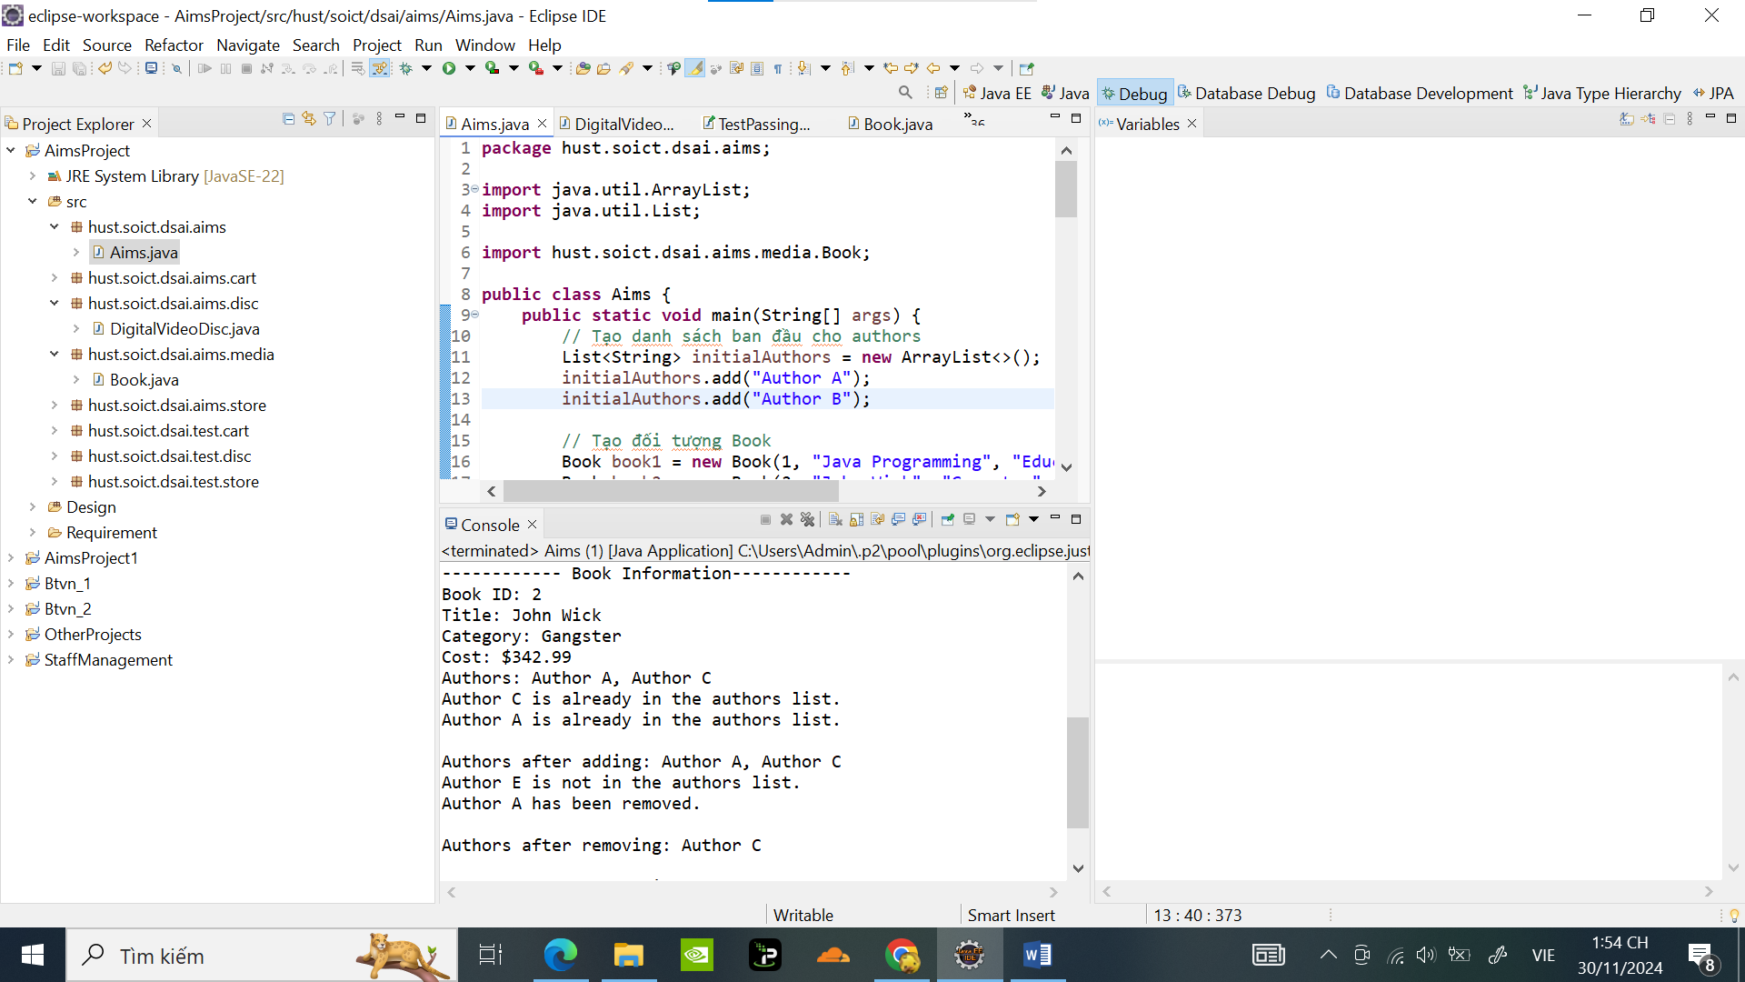

Kết quả :

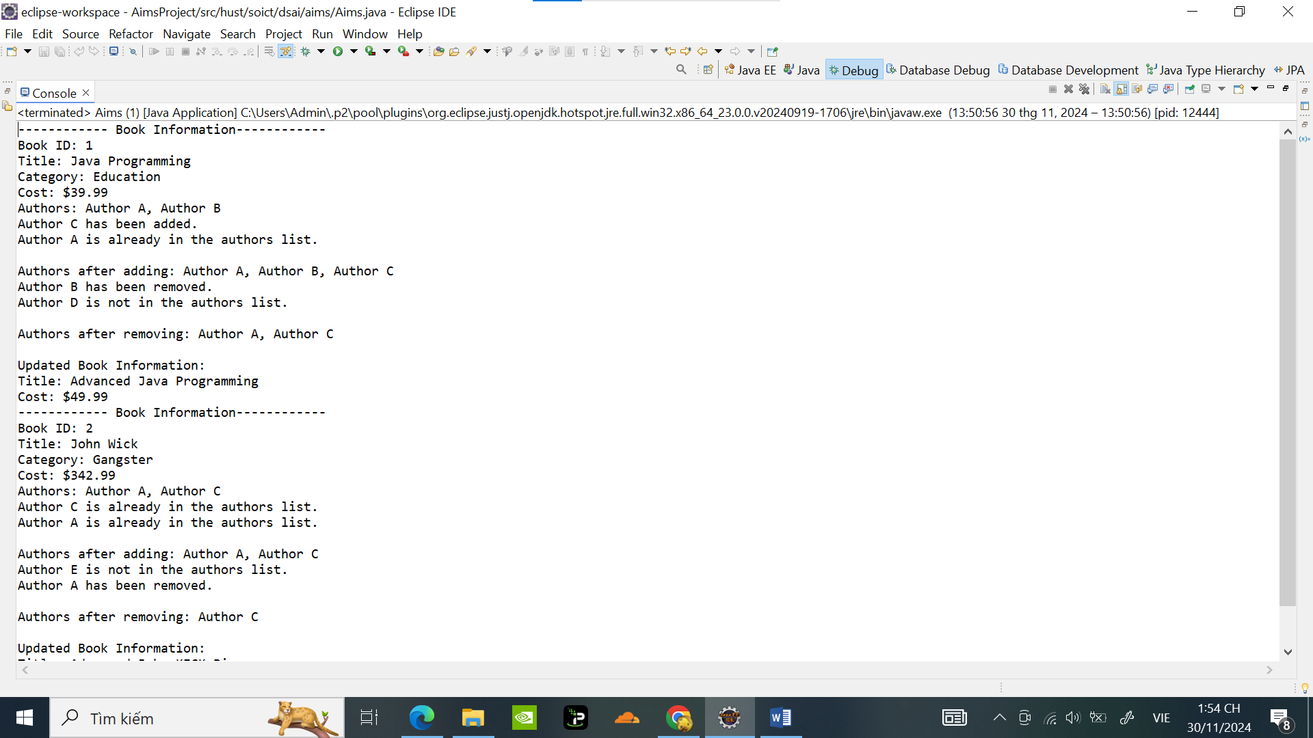

1. **Creating the abstract Media class**

Code Tạo Media class :

**package** hust.soict.dsai.aims.media;

**public** **abstract** **class** Media {

**private** **int** id;

**private** String title;

**private** String category;

**private** **float** cost;

**private** **static** **int** *nbDigitalVideoDiscs* = 0;

**public** Media(**int** id, String title, String category, **float** cost) {

// **TODO** Auto-generated constructor stub

**this**.title = title;

**this**.category = category;

**this**.cost = cost;

*nbDigitalVideoDiscs*++;

**this**.id = *nbDigitalVideoDiscs*;

}

**public** **int** getId() {

**return** id;

}

**public** **void** setId(**int** id) {

**this**.id = id;

}

**public** String getTitle() {

**return** title;

}

**public** **void** setTitle(String title) {

**this**.title = title;

}

**public** String getCategory() {

**return** category;

}

**public** **void** setCategory(String category) {

**this**.category = category;

}

**public** **float** getCost() {

**return** cost;

}

**public** **void** setCost(**float** cost) {

**this**.cost = cost;

}

**public** **static** **int** getNbDigitalVideoDiscs() {

**return** *nbDigitalVideoDiscs*;

}

**public** **boolean** isMatch(String title2) {

// **TODO** Auto-generated method stub

**return** **false**;

}

}

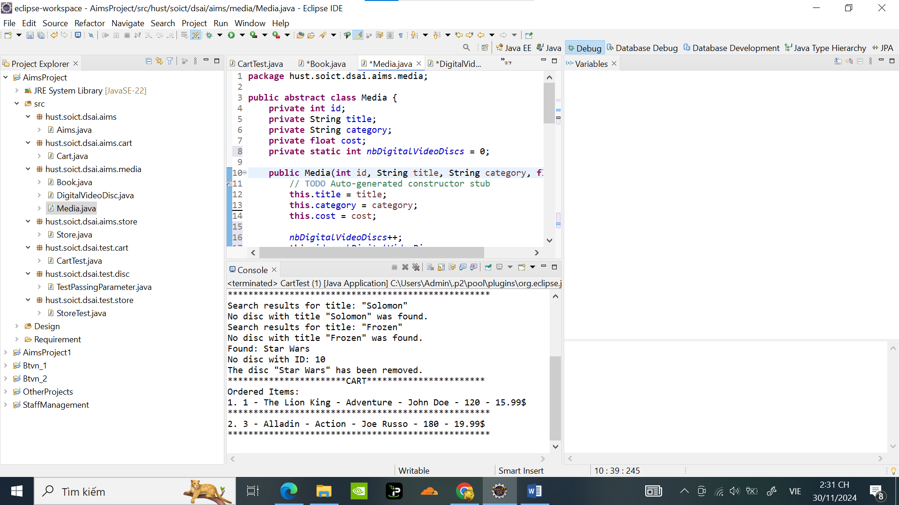

Sưa code của class Book để extend Media:

**package** hust.soict.dsai.aims.media;

**import** java.util.ArrayList;

**import** java.util.List;

**public** **class** Book **extends** Media {

**private** List<String> authors = **new** ArrayList<>();

**public** Book(**int** id, String title, String category, **float** cost , List<String> authors ) {

// **TODO** Auto-generated constructor stub

**super**(id, title, category, cost);

**this**.authors = authors;

}

**public** **void** setAuthors(List<String> authors) {

**this**.authors = authors;

}

**public** **void** addAuthor(String authorName) {

**if** (!authors.contains(authorName)) { // Check if the author is not already in the list

authors.add(authorName); // Add the author if not present

System.***out***.println(authorName + " has been added.");

} **else** {

System.***out***.println(authorName + " is already in the authors list.");

}

}

// Method to remove an author from the authors list

**public** **void** removeAuthor(String authorName) {

**if** (authors.contains(authorName)) { // Check if the author is in the list

authors.remove(authorName); // Remove the author

System.***out***.println(authorName + " has been removed.");

} **else** {

System.***out***.println(authorName + " is not in the authors list.");

}

}

// Utility method to display all authors (for testing purposes)

**public** String getAuthorsAsString() {

**return** String.*join*(", ", authors);

}

}

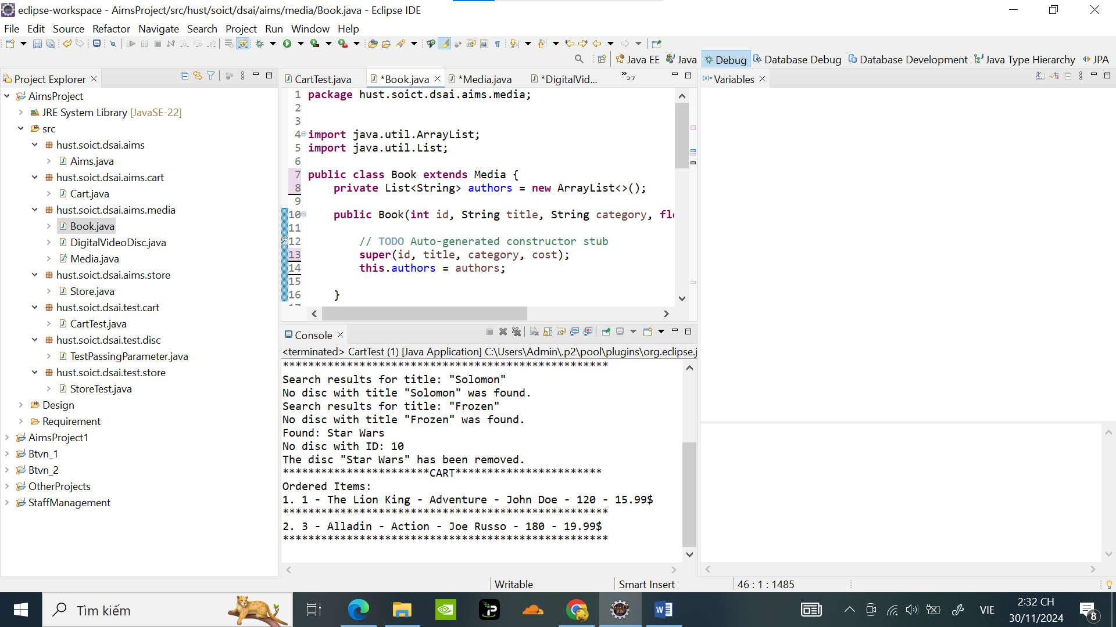

Sửa code DigitalVideoDisc để extend với Media:

**package** hust.soict.dsai.aims.media;

**public** **class** DigitalVideoDisc **extends** Media{

**private** **int** length;

**private** String director;

**public** DigitalVideoDisc(**int** id,String title, String category, String director, **int** length, **float** cost) {

**super**(id, title, category, cost);

**this**.director = director;

**this**.length = length;

}

**public** **int** getLength() {

**return** length;

}

**public** String getDirector() {

**return** director;

}

**public** **void** setDirector(String directorSet) {

**this**.director = directorSet;

}

**public** **boolean** isMatch(String title2) {

// **TODO** Auto-generated method stub

**return** **false**;

}

}

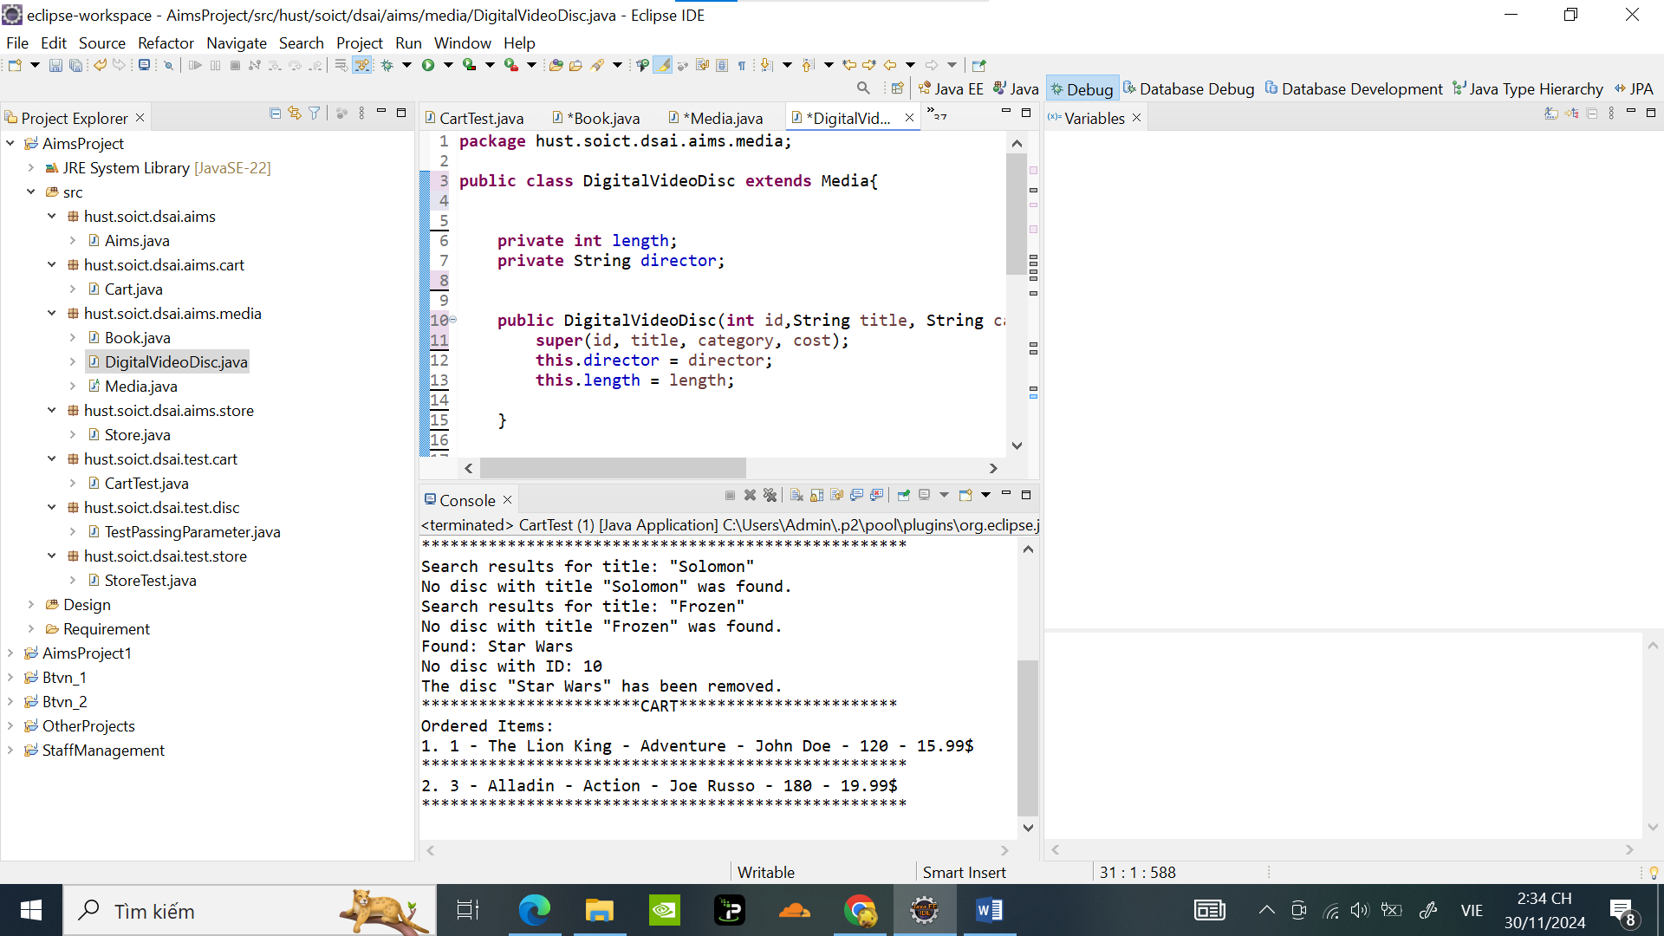

1. **Creating the CompactDisc class:**
   1. Create the Disc class extending the Media class:

Code tạo Disc Class:

**package** hust.soict.dsai.aims.media;

**public** **class** Disc **extends** Media {

**private** **int** length;

**private** String director;

**public** Disc(String title, String category,String director, **int** length,**float** cost) {

**super**( title, category, cost);

**this**.director = director;

**this**.length = length;

}

**public** Disc(String title) {

**super**( title);

**this**.director = "";

**this**.length = 0;

}

**public** **int** getLength() {

**return** length;

}

**public** String getDirector() {

**return** director;

}

}

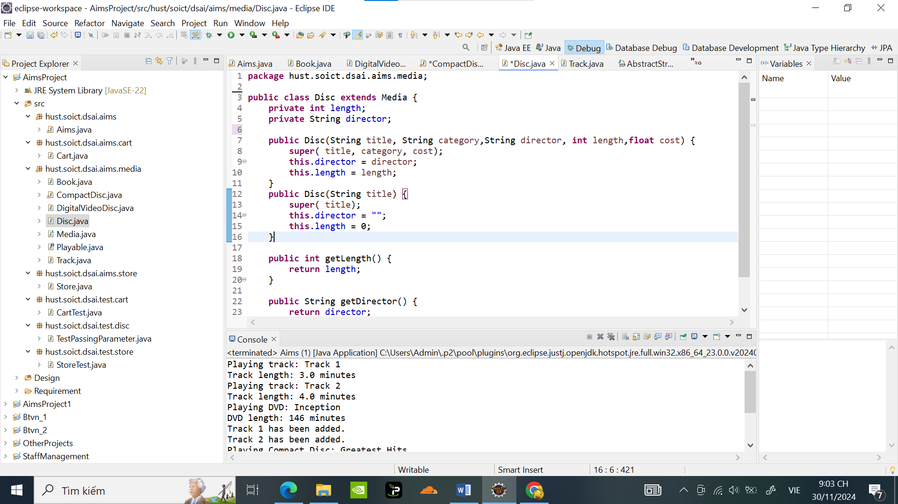

Sửa lại code DigitalVideoDisc để extends với Disc:

**package** hust.soict.dsai.aims.media;

**public** **class** DigitalVideoDisc **extends** Disc **implements** Playable{

**public** DigitalVideoDisc(String title, String category, String director, **int** length, **float** cost) {

**super**( title, category, director, length , cost);

}

**public** DigitalVideoDisc(String title) {

**super**( title);

}

**public** **void** play() {

// Triển khai phương thức play() cho DigitalVideoDisc

System.***out***.println("Playing DVD: " + **this**.getTitle());

System.***out***.println("DVD length: " + **this**.getLength() + " minutes");

}

**public** **boolean** isMatch(String title2) {

// **TODO** Auto-generated method stub

**return** **false**;

}

}

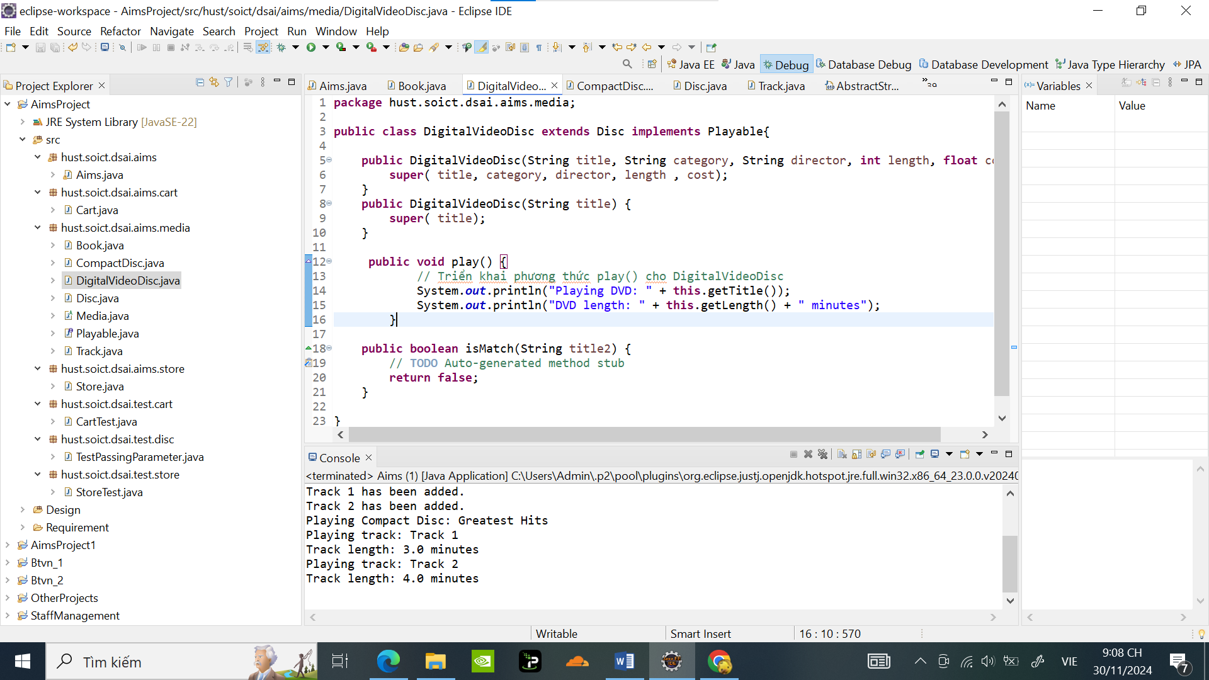

* 1. Create the Track class which models a track on a compact disc and will store information

Code tạo Track Class:

**package** hust.soict.dsai.aims.media;

**import** java.util.ArrayList;

**public** **class** Track **implements** Playable {

**private** String title;

**private** **float** length;

**public** Track(String title, **float** length) {

**this**.title= title;

**this**.length=length;

}

@Override

**public** **void** play() {

System.***out***.println("Playing track: " + **this**.title);

System.***out***.println("Track length: " + **this**.length + " minutes");

}

**public** String getTitle() {

**return** title;

}

**public** **void** setTitle(String title) {

**this**.title = title;

}

**public** **float** getLength() {

**return** length;

}

**public** **void** setLength(**float** length) {

**this**.length = length;

}

**public** **static** Track join(String string, ArrayList<Track> tracks) {

// **TODO** Auto-generated method stub

**return** **null**;

}

}

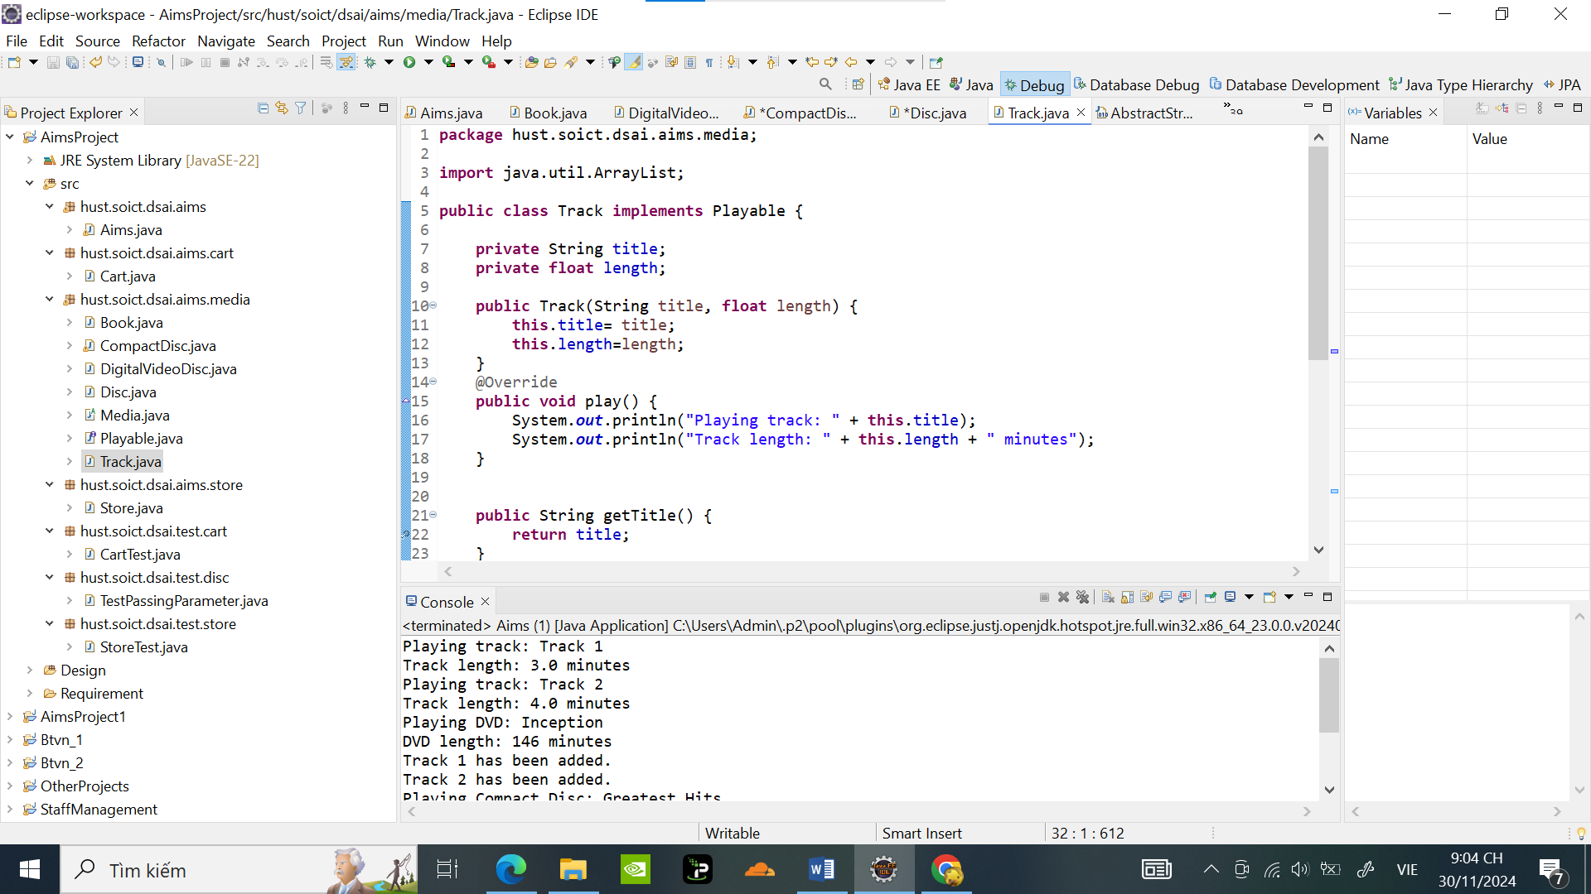

* 1. Open the CompactDisc class

Code tạo CompactDisc Class:

**package** hust.soict.dsai.aims.media;

**import** java.util.ArrayList;

**public** **class** CompactDisc **extends** Disc **implements** Playable {

**private** String artist;

**private** ArrayList<Track> Tracks = **new** ArrayList<>();

**public** CompactDisc(String title, String category,String director, **int** length,**float** cost, String artist) {

**super**( title, category, director, length , cost);

**this**.artist=artist;

// **TODO** Auto-generated constructor stub

}

**public** **void** play() {

**if** (Tracks.isEmpty()) {

System.***out***.println("No tracks to play on the Compact Disc: " + getTitle());

} **else** {

System.***out***.println("Playing Compact Disc: " + getTitle());

**for** (Track track : Tracks) {

track.play(); // Call play() on each Track

}

}

}

**public** String getArtist() {

**return** artist;

}

**public** **void** setArtist(String artist) {

**this**.artist = artist;

}

**public** **void** addTrack(Track Track) {

**if** (!Tracks.contains(Track)) { // Check if the author is not already in the list

Tracks.add(Track); // Add the author if not present

System.***out***.println(Track.getTitle() + " has been added.");

} **else** {

System.***out***.println(Track.getTitle()+ " is already in the Tracks list.");

}

}

// Method to remove an author from the authors list

**public** **void** removeTrack(Track Track) {

**if** (Tracks.contains(Track)) { // Check if the author is in the list

Tracks.remove(Track); // Remove the author

System.***out***.println( Track.getTitle()+ " has been removed.");

} **else** {

System.***out***.println(Track.getTitle() + " is not in the Tracks list.");

}

}

// Utility method to display all authors (for testing purposes)

**public** Track getTracksAsString() {

**return** Track.*join*(", ", Tracks);

}

}

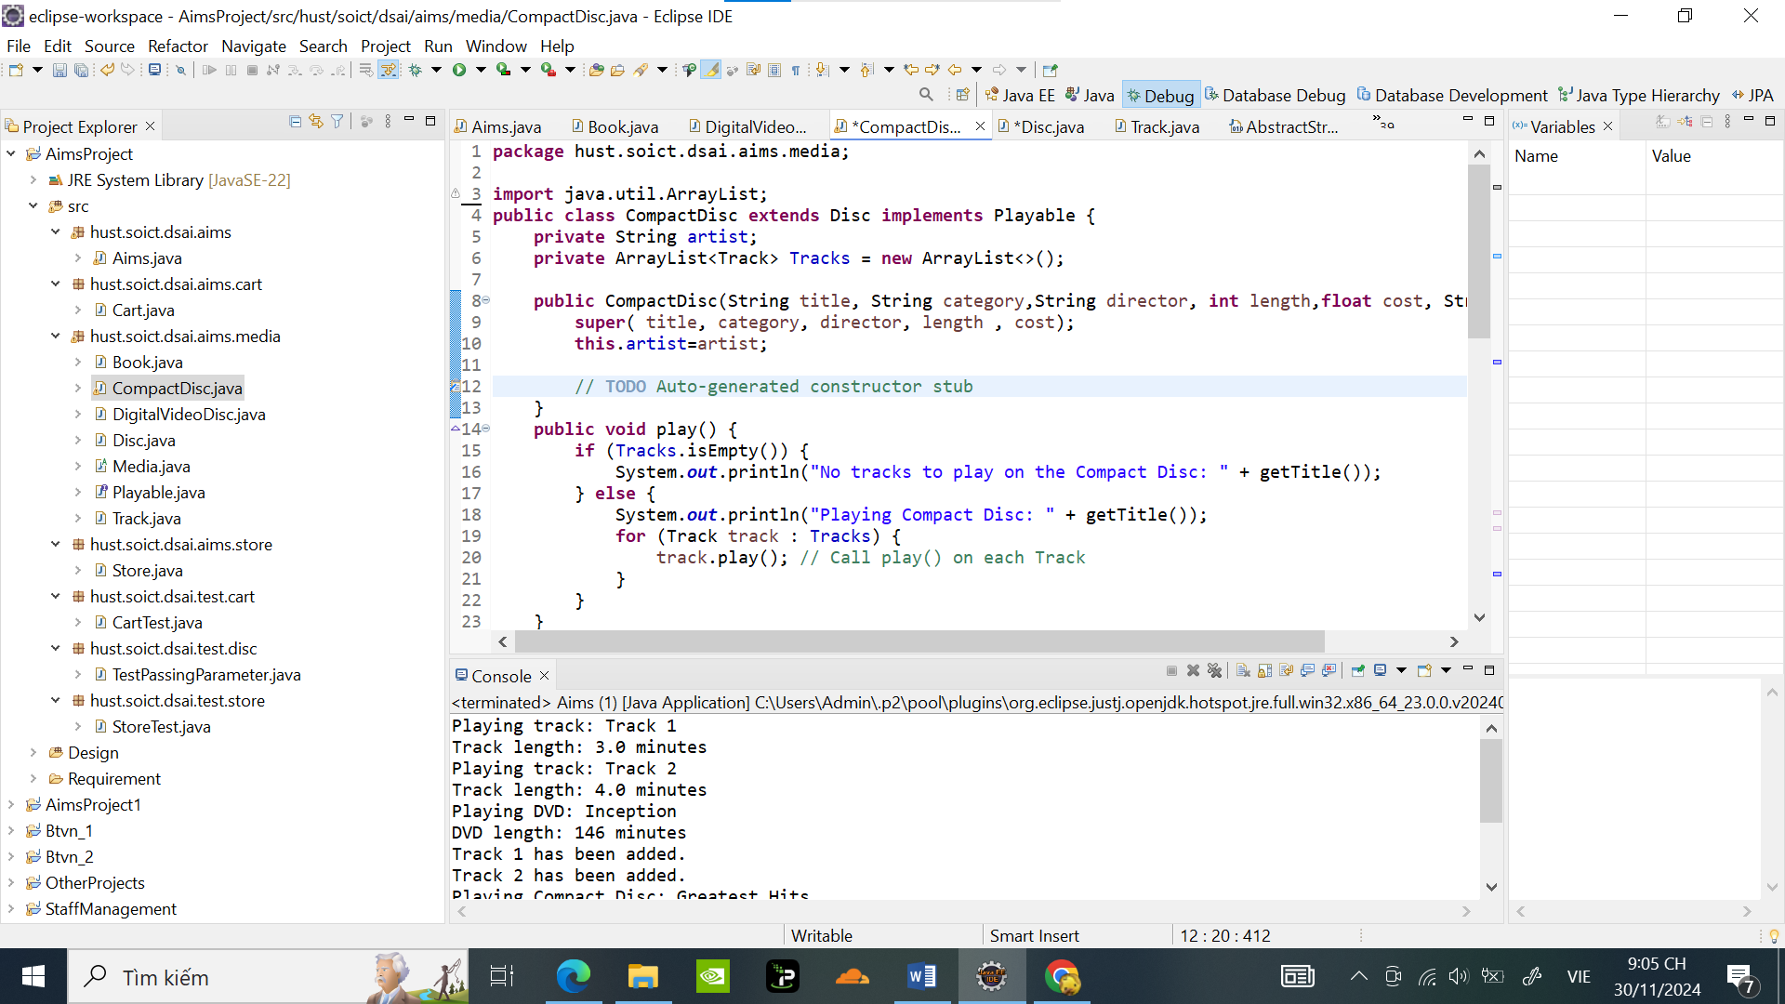

1. **Create the Playable interface**

Tạo Playable interface

**package** hust.soict.dsai.aims.media;

**public** **interface** Playable {

**public** **void** play();

}

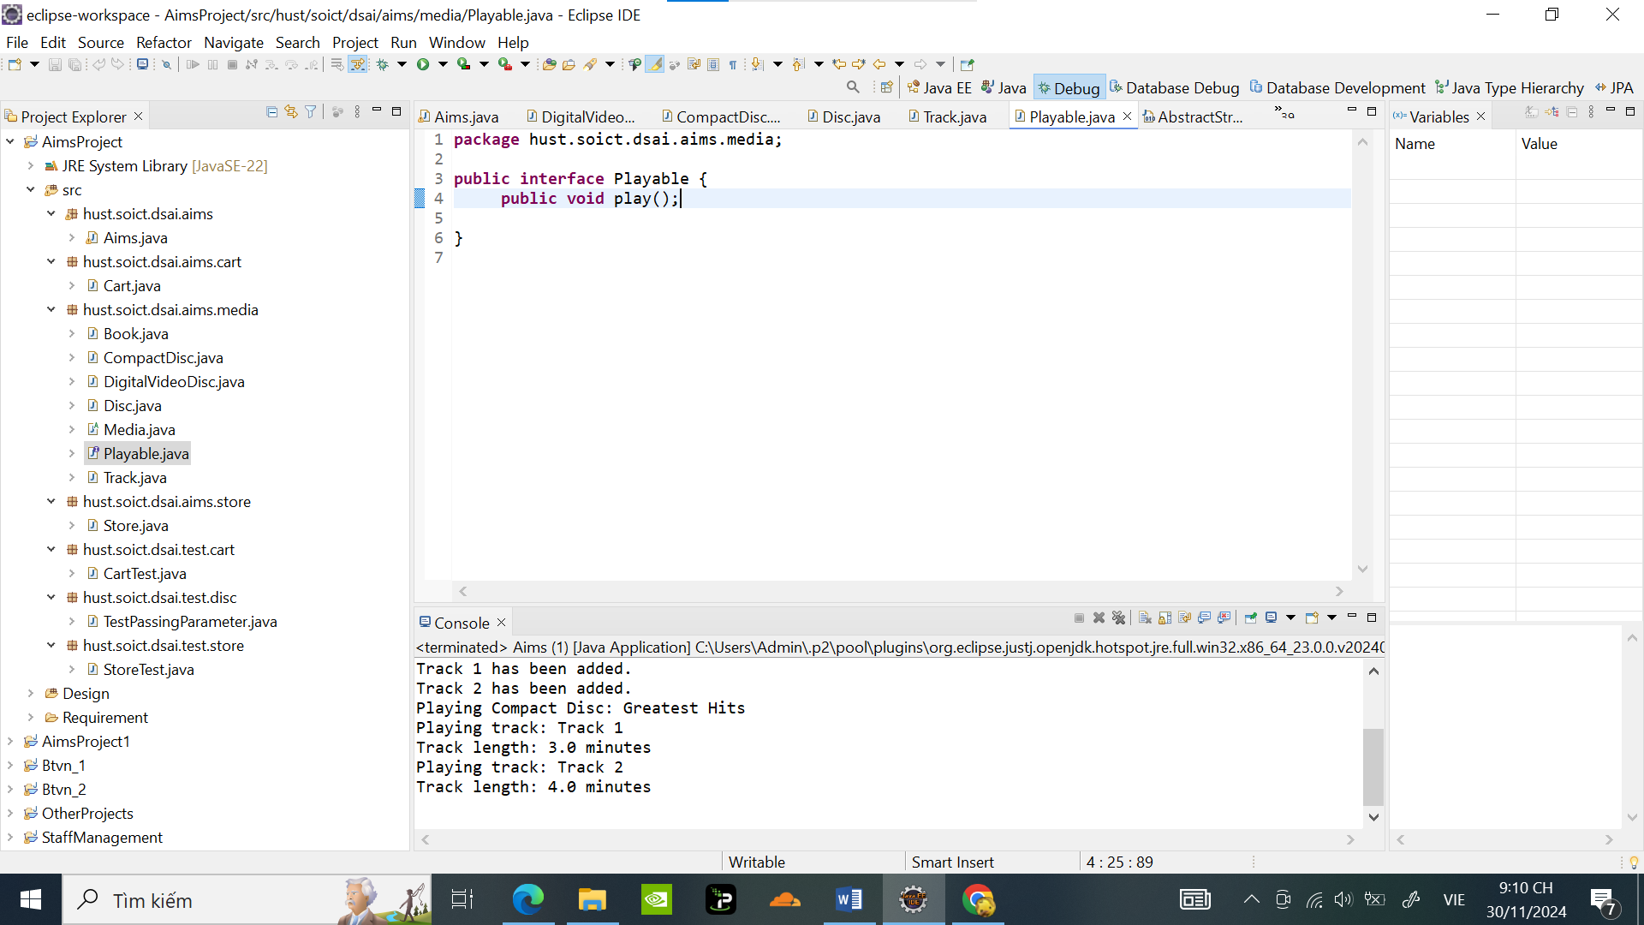

Sửa đổi để thêm implements và play() cho các class CompactDisc,Track,DigitalVideoDisc ( Đã được viết tại **5.** **Creating the CompactDisc class )**

Test thử trong Aims class :

**public** **class** Aims {

**public** **static** **void** main(String[] args) {

// Test Track class

Track track1 = **new** Track("Track 1", 3);

Track track2 = **new** Track("Track 2", 4);

track1.play();

track2.play();

// Test DigitalVideoDisc class

DigitalVideoDisc dvd = **new** DigitalVideoDisc( "Inception", "Sci-fi","Goal", 146 ,19.99f );

dvd.play();

// Test CompactDisc class

CompactDisc cd = **new** CompactDisc( "Greatest Hits", "Pop","J-97",0,19.99f,"Gomen");

cd.addTrack(track1);

cd.addTrack(track2);

cd.play();

}

}

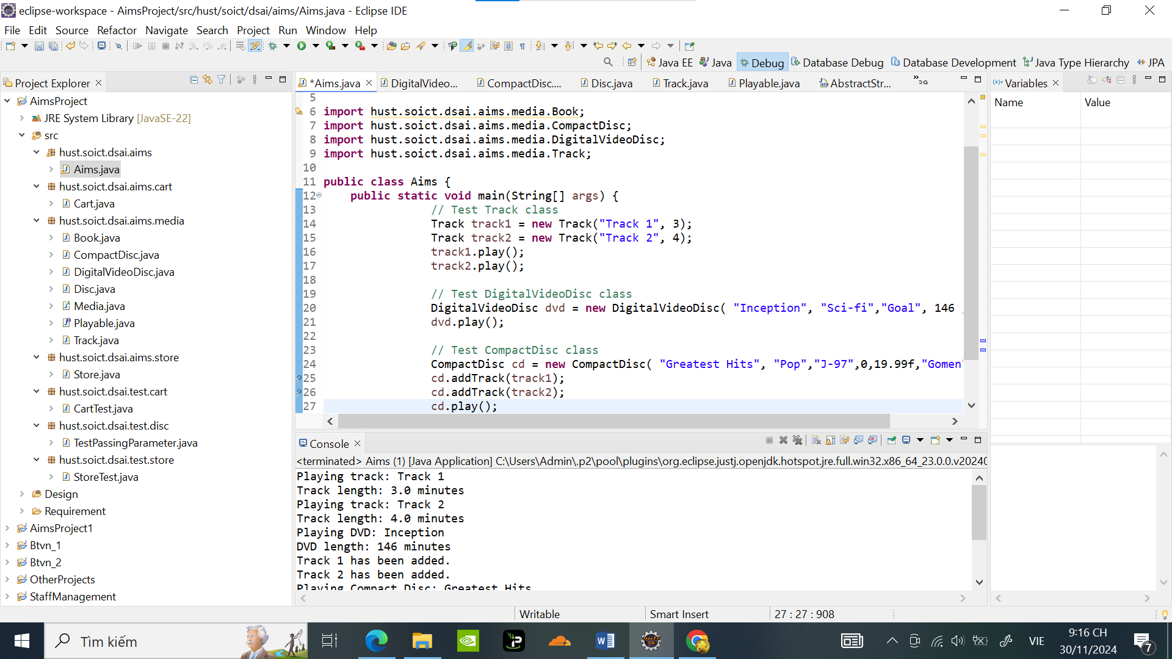

Kết quả :

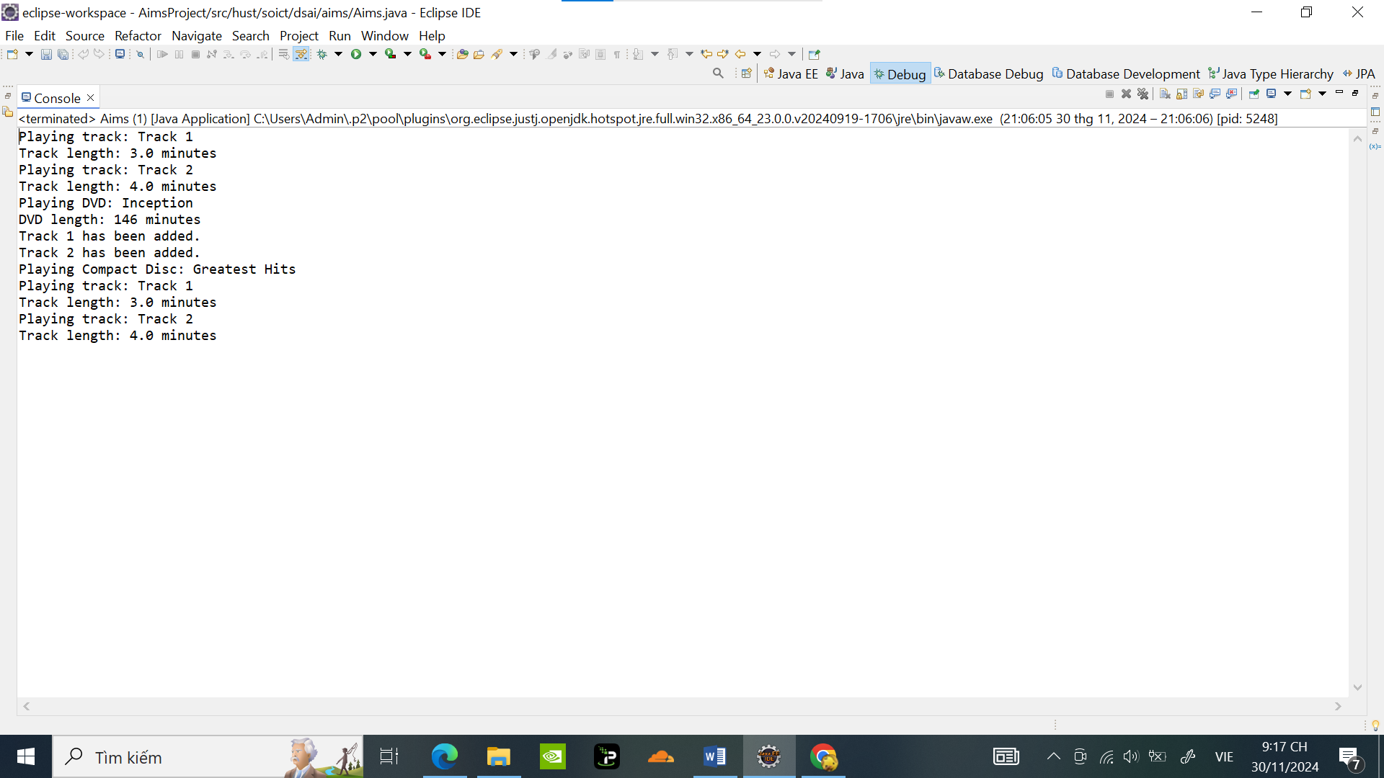

1. **Update the Cart class to work with Media**

Update the Cart Class:

**package** hust.soict.dsai.aims.cart;

**import** java.util.ArrayList;

**import** hust.soict.dsai.aims.media.Media;

**public** **class** Cart {

**private** ArrayList<Media> itemsOrdered = **new** ArrayList<>();

// Constructor (nếu cần)

**public** Cart() {

}

**public** **void** addMedia(Media media) {

**if** (media != **null**) {

itemsOrdered.add(media);

System.***out***.println("Added: " + media.getTitle());

} **else** {

System.***out***.println("Cannot add a null item.");

}

}

**public** **void** removeMedia(Media media) {

**if** (itemsOrdered.contains(media)) {

itemsOrdered.remove(media);

System.***out***.println("Removed: " + media.getTitle());

} **else** {

System.***out***.println("Item not found: " + (media != **null** ? media.getTitle() : "null"));

}

}

**public** **float** totalCost() {

**float** total = 0;

**for** (Media media : itemsOrdered) {

total += media.getCost();

}

**return** total;

}

**public** **void** printCart() {

System.***out***.println("*********************** CART ***********************");

System.***out***.println("Ordered Items:");

**float** totalCost = 0;

**int** index = 1;

**for** (Media media : itemsOrdered) {

System.***out***.println(index++ + ". " + media.getTitle());

totalCost += media.getCost();

}

System.***out***.println("Total cost: " + totalCost + " $");

System.***out***.println("***************************************************");

}

**public** **void** searchByTitle(String title) {

**boolean** found = **false**;

System.***out***.println("Search results for title: \"" + title + "\"");

**for** (Media media : itemsOrdered) {

**if** (media.getTitle().equalsIgnoreCase(title)) {

System.***out***.println(media.getTitle());

found = **true**;

}

}

**if** (!found) {

System.***out***.println("No media found with title: \"" + title + "\".");

}

}

**public** **void** searchById(**int** id) {

**boolean** found = **false**;

**for** (Media media : itemsOrdered) {

**if** (media.getId() == id) {

System.***out***.println("Found: " + media.getTitle());

found = **true**;

**break**;

}

}

**if** (!found) {

System.***out***.println("No media found with ID: " + id);

}

}

**public** ArrayList<Media> getItemsOrdered() {

**return** itemsOrdered;

}

**public** **void** setItemsOrdered(ArrayList<Media> itemsOrdered) {

**this**.itemsOrdered = itemsOrdered;

}

}

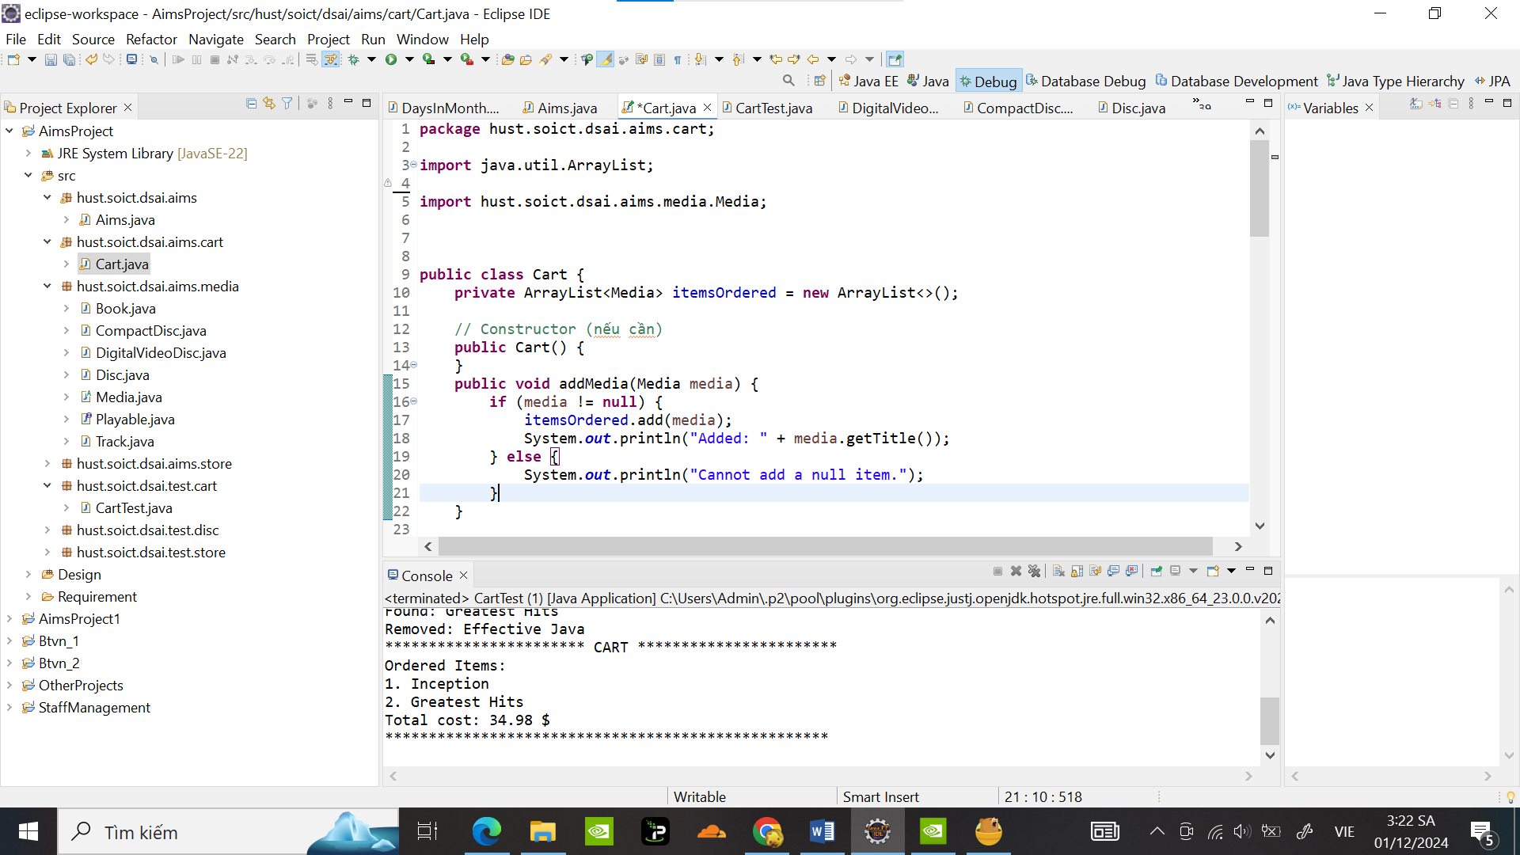

Kiểm tra thử trong CartTest:

**package** hust.soict.dsai.test.cart;

**import** java.util.ArrayList;

**import** hust.soict.dsai.aims.cart.Cart;

**import** hust.soict.dsai.aims.media.Book;

**import** hust.soict.dsai.aims.media.CompactDisc;

**import** hust.soict.dsai.aims.media.DigitalVideoDisc;

**public** **class** CartTest {

**public** **static** **void** main(String[] args) {

Cart cart = **new** Cart();

// Tạo các đối tượng Media

DigitalVideoDisc dvd = **new** DigitalVideoDisc( "Inception", "Sci-Fi", "Christopher Nolan", 148, 19.99f);

Book book = **new** Book( "Effective Java", "Programming", 45.99f, **new** ArrayList<>());

CompactDisc cd = **new** CompactDisc("Greatest Hits", "Music","Godfather" ,134, 14.99f,"J-97");

// Thêm các mục vào giỏ hàng

cart.addMedia(dvd);

cart.addMedia(book);

cart.addMedia(cd);

// In giỏ hàng

cart.printCart();

// Tìm kiếm theo tiêu đề

cart.searchByTitle("Effective Java");

// Tìm kiếm theo ID

cart.searchById(3);

// Xóa mục khỏi giỏ hàng

cart.removeMedia(book);

// In lại giỏ hàng

cart.printCart();

}

}

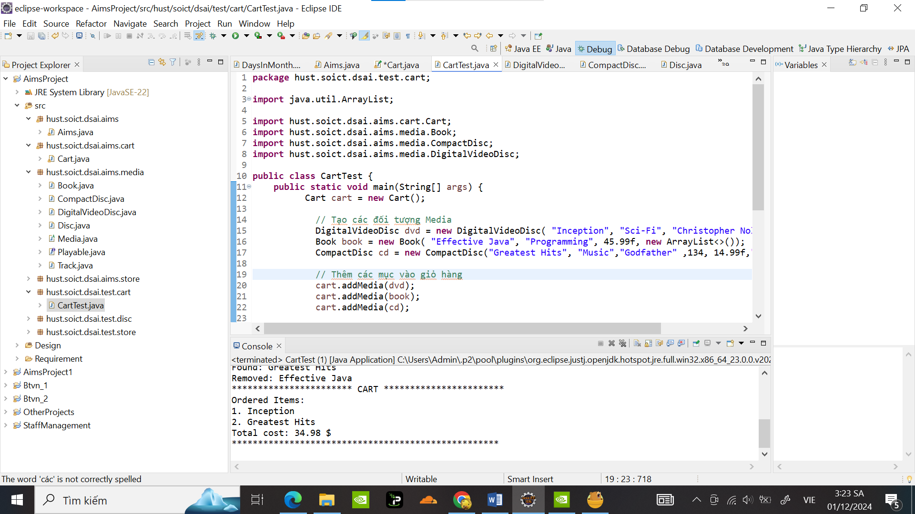

Kết quả :

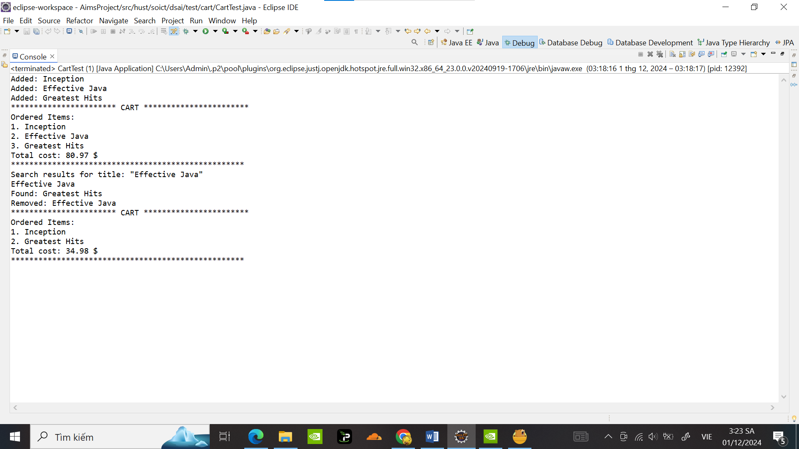

1. **Update the Store class to work with Media:**

Update the Store Class:

**package** hust.soict.dsai.aims.store;

**import** hust.soict.dsai.aims.media.Media;

**import** java.util.ArrayList;

**public** **class** Store {

**private** ArrayList<Media> itemsInStore;

**public** Store() {

itemsInStore = **new** ArrayList<>();

}

// Check if a Media item exists in the store

**public** **boolean** checkMedia(Media media) {

**return** itemsInStore.contains(media);

}

// Add a Media item to the store

**public** **void** addMedia(Media media) {

**if** (!checkMedia(media)) {

itemsInStore.add(media);

System.***out***.println(media.getTitle() + " has been added to the store.");

} **else** {

System.***out***.println(media.getTitle() + " already exists in the store.");

}

}

// Remove a Media item from the store

**public** **void** removeMedia(Media media) {

**if** (checkMedia(media)) {

itemsInStore.remove(media);

System.***out***.println(media.getTitle() + " has been removed from the store.");

} **else** {

System.***out***.println(media.getTitle() + " is not found in the store.");

}

}

// Print the contents of the store

@Override

**public** String toString() {

StringBuilder storeContents = **new** StringBuilder("-----------Store contents:-------------\n");

**for** (Media media : itemsInStore) {

storeContents.append(media.getTitle()).append("\n");

}

**return** storeContents.toString();

}

}

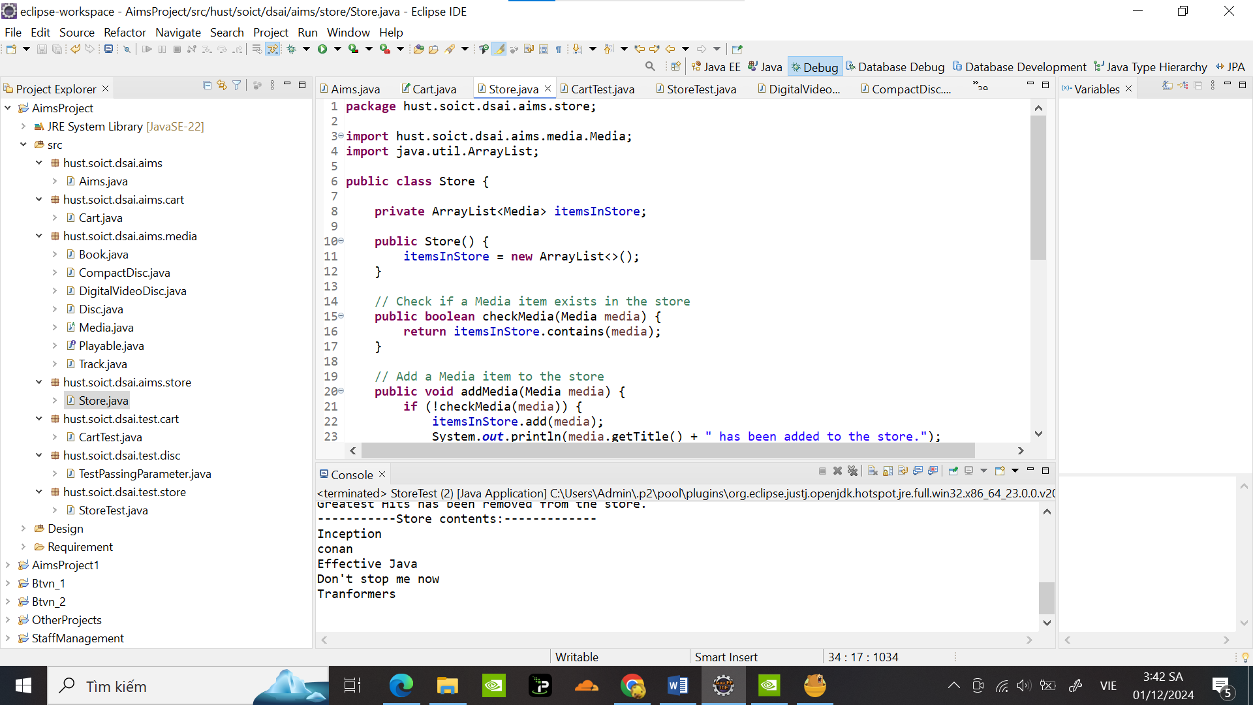

Test thử trong StoreTest:

**package** hust.soict.dsai.test.store;

**import** hust.soict.dsai.aims.media.DigitalVideoDisc;

**import** hust.soict.dsai.aims.media.Book;

**import** hust.soict.dsai.aims.media.CompactDisc;

**import** hust.soict.dsai.aims.store.Store;

**import** java.util.ArrayList;

**public** **class** StoreTest {

**public** **static** **void** main(String[] args) {

Store store = **new** Store();

// Create Media objects

DigitalVideoDisc dvd1 = **new** DigitalVideoDisc( "Inception", "Sci-Fi", "Christopher Nolan", 148, 19.99f);

DigitalVideoDisc dvd2 = **new** DigitalVideoDisc( "Tranformers", "action", "Micheal Bay", 198, 39.99f);

Book book1 = **new** Book( "conan", "anime", 15.99f, **new** ArrayList<>());

Book book2 = **new** Book( "doraemon", "anime", 12.45f, **new** ArrayList<>());

Book book3 = **new** Book( "Effective Java", "Programming", 45.99f, **new** ArrayList<>());

CompactDisc cd1 = **new** CompactDisc("Greatest Hits", "Music","Godfather" ,134, 14.99f,"J-97");

CompactDisc cd2 = **new** CompactDisc("Don't stop me now", "Music","Mamaday" ,167, 22.99f,"hololive");

// Add Media items to the store

store.addMedia(dvd1);

store.addMedia(book1);

store.addMedia(book2);

store.addMedia(book3);

store.addMedia(cd1);

store.addMedia(cd2);

// Try adding duplicate

store.addMedia(dvd2);

// Print store contents

System.***out***.println(store);

// Remove a Media item

store.removeMedia(book2);

store.removeMedia(cd1);

// Print store contents after removal

System.***out***.println(store);

}

}

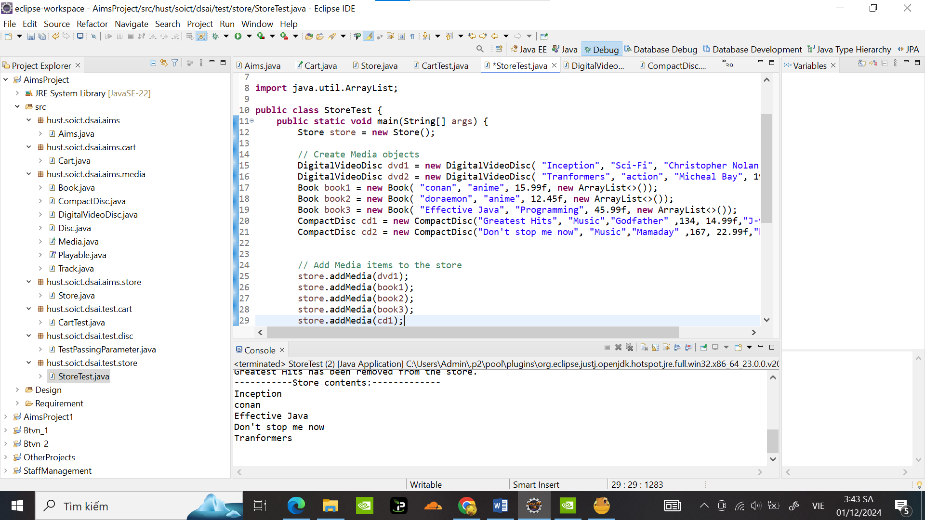

Kết quả :

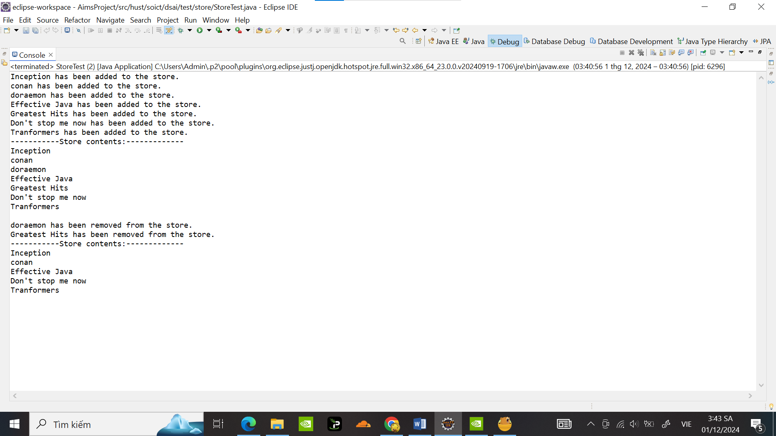

1. **Constructors of whole classes and parent classes**

Sửa class diagram:

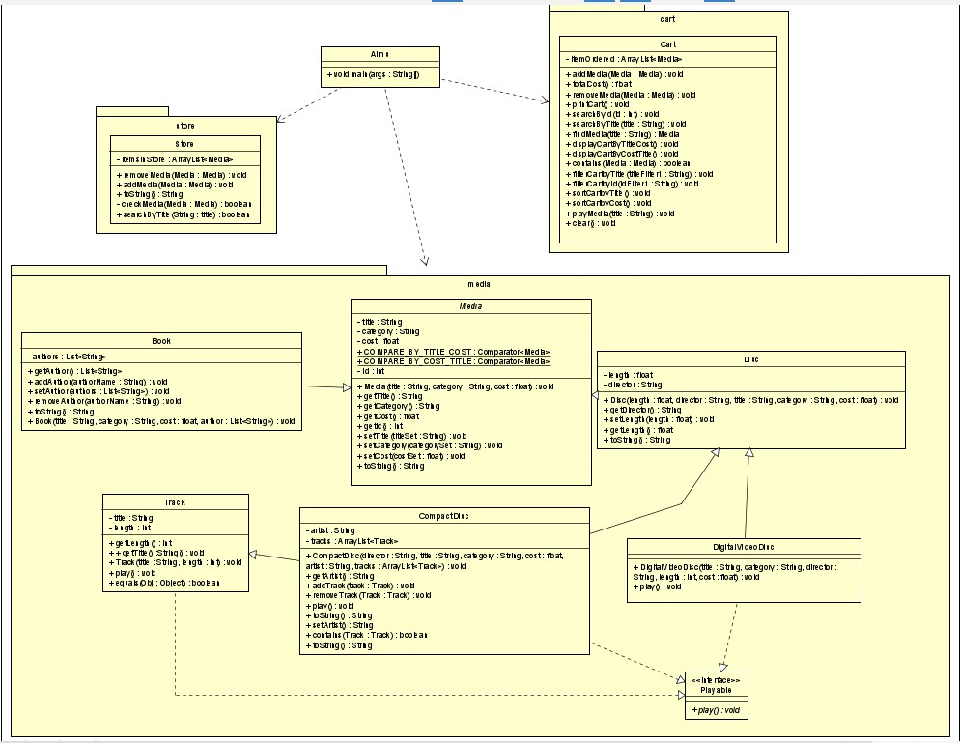

Class Media là cha của các class CompactDisc, Disc, DigitalVideoDisc và Book

1. **Unique item in a list**

Sửa đổi Media class check 2 media cùng title khi add :

@Override

**public** **boolean** equals(Object obj) {

**if** (**this** == obj) { // Check if both references point to the same object

**return** **true**;

}

**if** (obj == **null** || getClass() != obj.getClass()) { // Check if obj is null or a different class

**return** **false**;

}

Media media = (Media) obj; // Cast obj to Media

**return** title != **null** && title.equals(media.title); // Check equality of titles

}

@Override

**public** **int** hashCode() {

**return** title != **null** ? title.hashCode() : 0; // Generate hashCode based on title

}

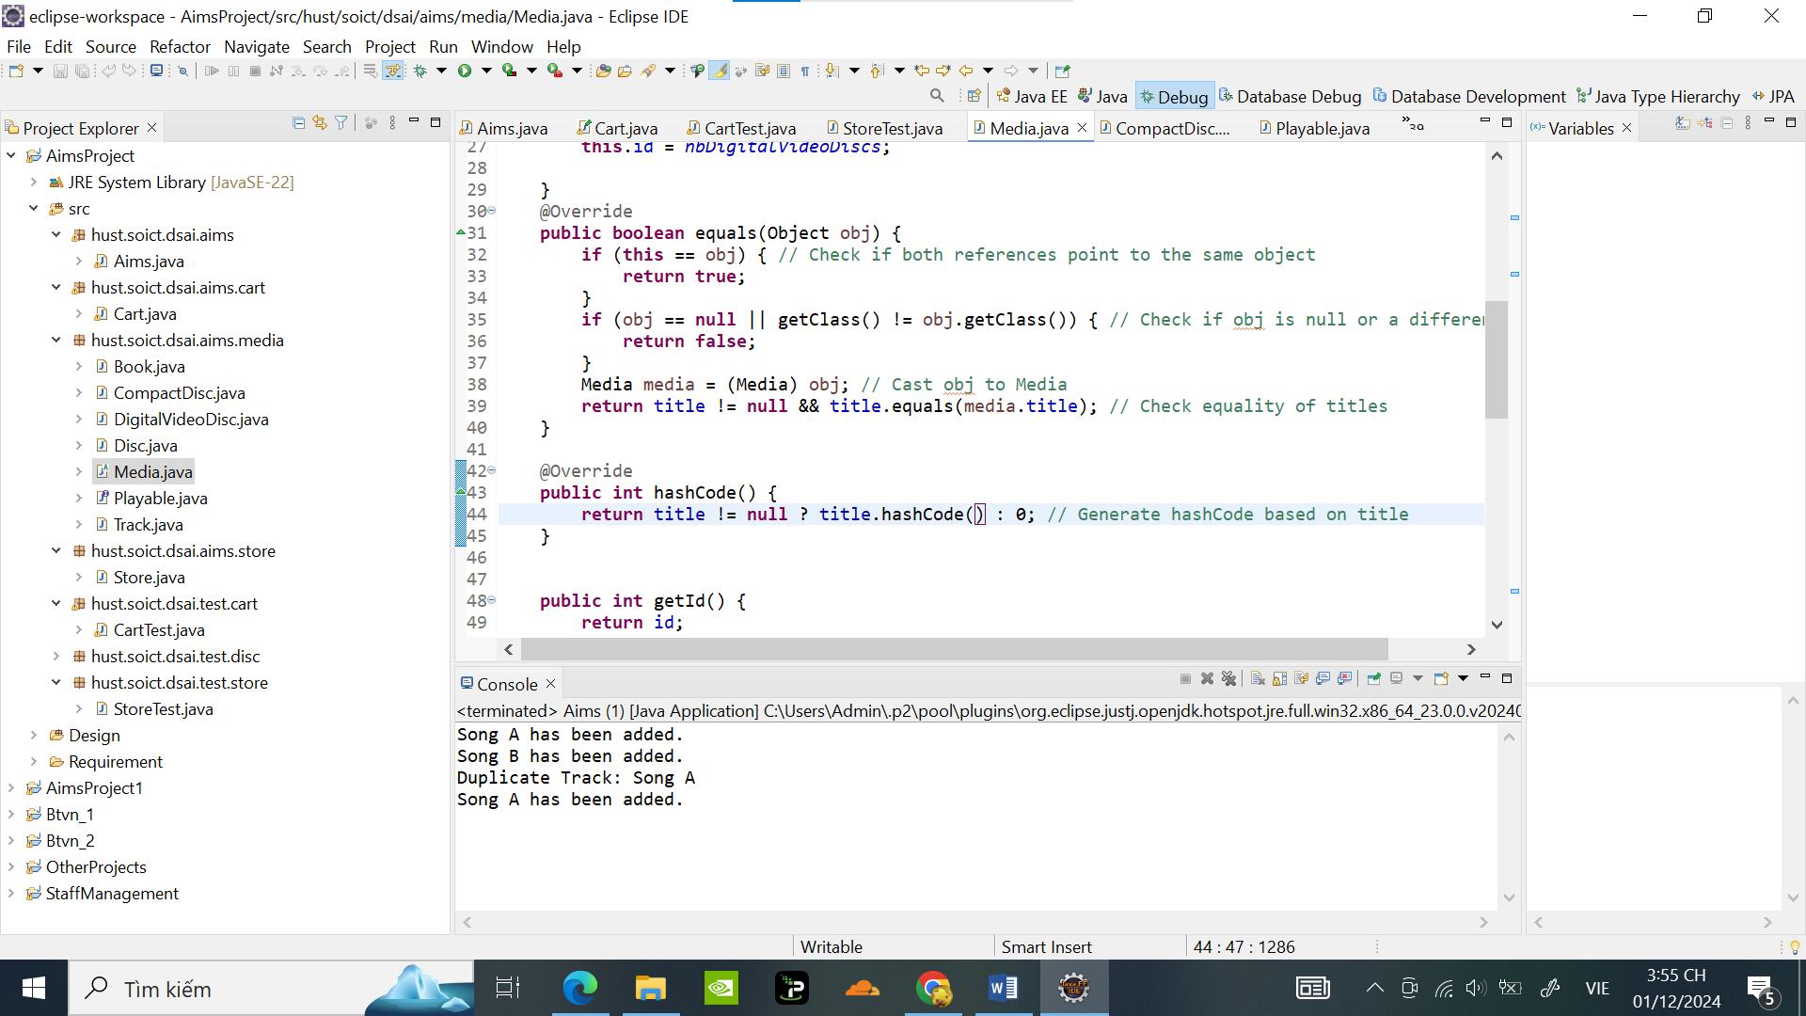

Code test trong CartTest để kiểm tra các media có cùng title khi add không:

**package** hust.soict.dsai.test.cart;

**import** java.util.ArrayList;

**import** hust.soict.dsai.aims.cart.Cart;

**import** hust.soict.dsai.aims.media.Book;

**import** hust.soict.dsai.aims.media.CompactDisc;

**import** hust.soict.dsai.aims.media.DigitalVideoDisc;

**public** **class** CartTest {

**public** **static** **void** main(String[] args) {

Cart cart = **new** Cart();

// Tạo các đối tượng Media

DigitalVideoDisc dvd1 = **new** DigitalVideoDisc( "Tranformers", "action", "Micheal Bay", 198, 39.99f);

DigitalVideoDisc dvd2 = **new** DigitalVideoDisc( "Inception", "Sci-Fi", "Christopher Nolan", 148, 19.99f);

DigitalVideoDisc dvd3 = **new** DigitalVideoDisc( "Inception", "Sci-Fi", "Christopher Nolan", 148, 19.99f);

Book book1 = **new** Book( "Effective Java", "Programming", 45.99f, **new** ArrayList<>());

Book book2 = **new** Book( "Effective Java", "Programming", 45.99f, **new** ArrayList<>());

CompactDisc cd1 = **new** CompactDisc("Greatest Hits", "Music","Godfather" ,134, 14.99f,"J-97");

CompactDisc cd2 = **new** CompactDisc("Don't stop me now", "Music","Mamaday" ,167, 22.99f,"hololive");

CompactDisc cd3 = **new** CompactDisc("Don't stop me now", "Music","Mamaday" ,167, 22.99f,"lolive");

cart.addMedia(dvd1);

cart.addMedia(dvd2);

cart.addMedia(book1);

cart.addMedia(cd1);

cart.printCart();

// Attempting to add duplicate

**if** (! cart.contains(dvd3)) {

cart.addMedia(dvd3);

} **else** {

System.***out***.println("Duplicate Media: " + dvd3.getTitle());

}

// Adding a different media

**if** (!cart.contains(book2)) {

cart.addMedia(book2);

}**else** {

System.***out***.println("Duplicate Media: " + book2.getTitle());

}

**if** (!cart.contains(cd2)) {

cart.addMedia(cd2);

}**else** {

System.***out***.println("Duplicate Media: " + cd2.getTitle());

}

**if** (!cart.contains(cd3)) {

cart.addMedia(cd3);

}**else** {

System.***out***.println("Duplicate Media: " + cd3.getTitle());

}

cart.printCart();

}

}

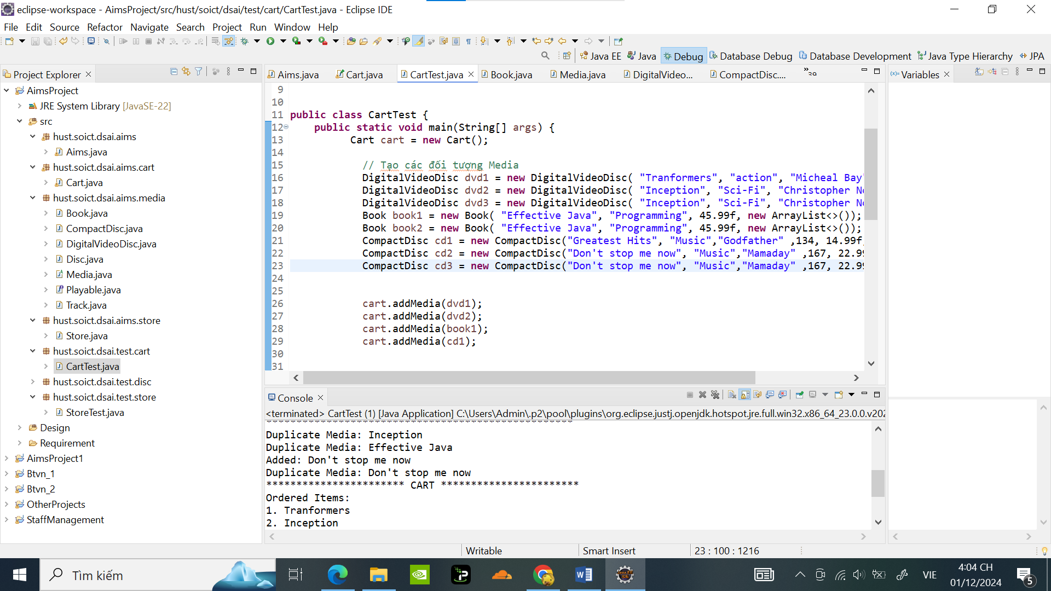

Kết quả :

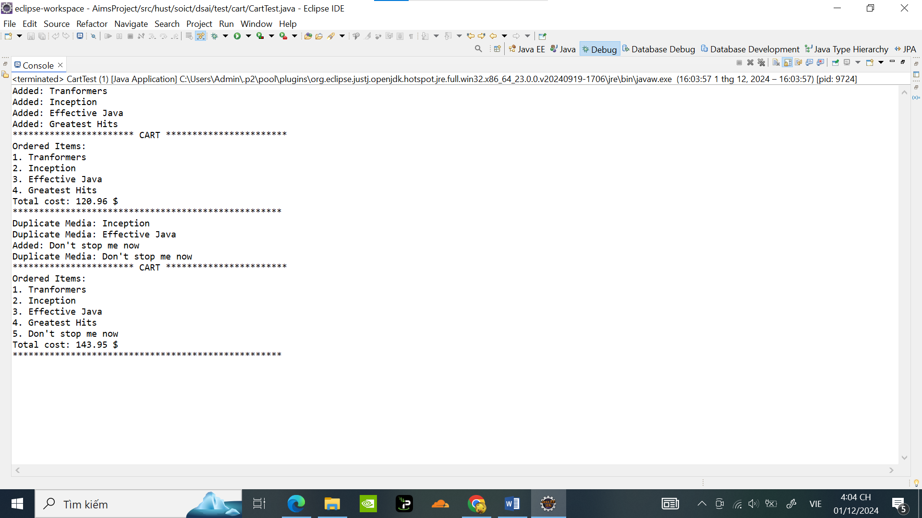

Sửa Track class check 2 track cùng title và length khi add vào cùng 1 cd :

@Override

**public** **boolean** equals(Object obj) {

**if** (**this** == obj) { // Check if both references point to the same object

**return** **true**;

}

**if** (obj == **null** || getClass() != obj.getClass()) { // Check if obj is null or a different class

**return** **false**;

}

Track track = (Track) obj; // Cast obj to Track

**return** length == track.length && title != **null** && title.equals(track.title); // Check equality of title and length

}

@Override

**public** **int** hashCode() {

**float** result;

**if** (title != **null**) {

result = title.hashCode(); // Lấy mã băm của title nếu không null

} **else** {

result = 0; // Nếu title là null, gán mã băm là 0

}

result = 31 *result + length; // Kết hợp thêm thuộc tính length

**return** (**int**)(result); // Trả về kết quả mã băm dạng số nguyên

}

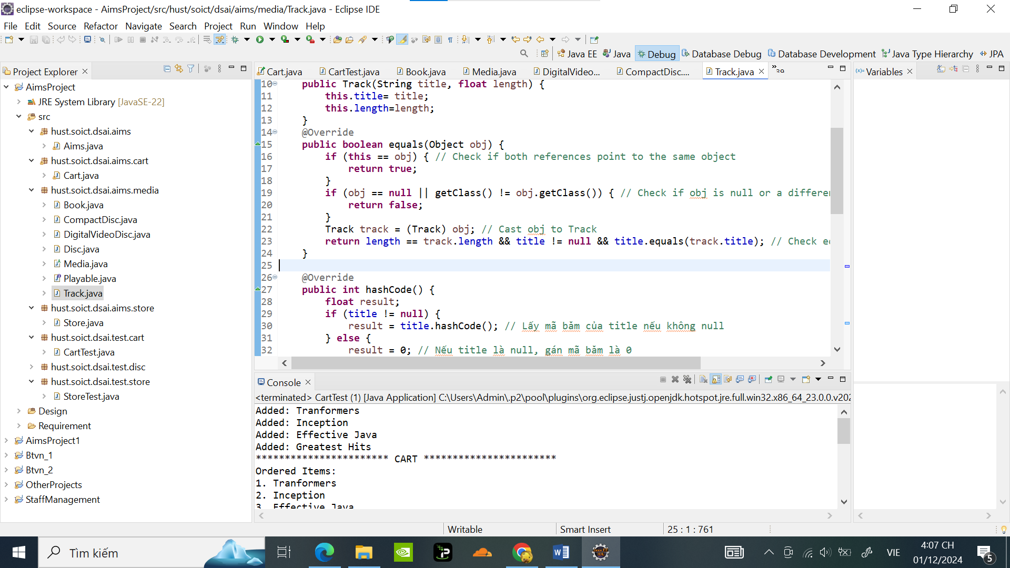

Khi cùng add vào 1 cd2, code test trong AimsClass:

**public** **class** Aims {

**public** **static** **void** main(String[] args) {

CompactDisc cd2 = **new** CompactDisc("Don't stop me now", "Music","Mamaday" ,167, 22.99f,"hololive");

Track track1 = **new** Track("Song A", 200);

Track track2 = **new** Track("Song B", 180);

Track Track3 = **new** Track("Song A", 200);

Track Track4 = **new** Track("Song A", 180);

cd2.addTrack(track1);

cd2.addTrack(track2);

**if** (!cd2.contains(Track3)) {

cd2.addTrack(Track3);

} **else** {

System.***out***.println("Duplicate Track: " + Track3.getTitle());

}

**if** (!cd2.contains(Track4)) {

cd2.addTrack(Track4);

} **else** {

System.***out***.println("Duplicate Track: " + Track4.getTitle());

}

}

}

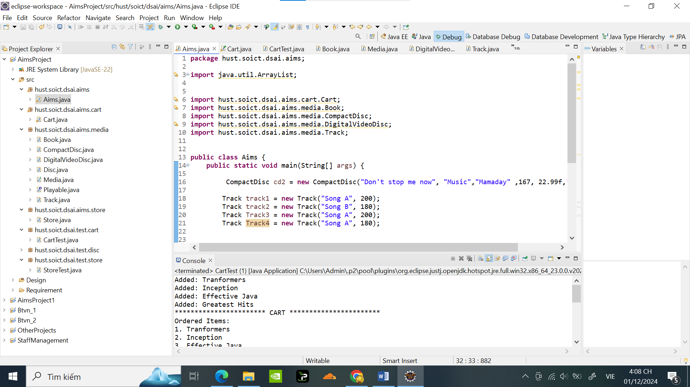

Kết quả : 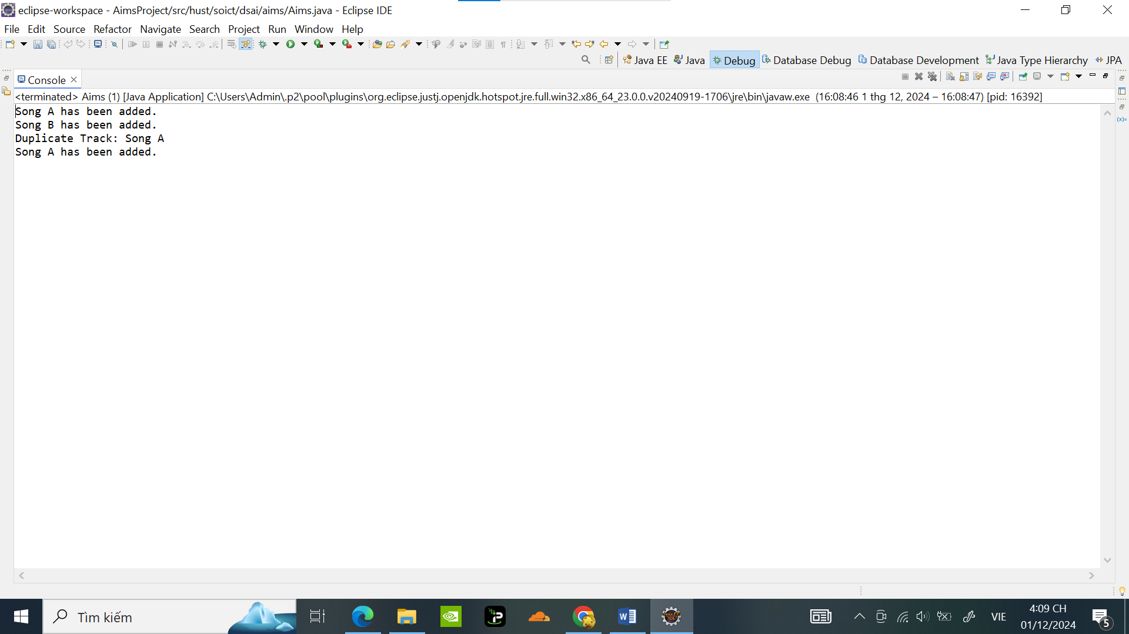

1. **Polymorphism with toString() method**

Code test toString() trong AimsClass:

**package** hust.soict.dsai.aims;

**import** java.util.ArrayList;

**import** hust.soict.dsai.aims.cart.Cart;

**import** hust.soict.dsai.aims.media.Book;

**import** hust.soict.dsai.aims.media.CompactDisc;

**import** hust.soict.dsai.aims.media.DigitalVideoDisc;

**import** hust.soict.dsai.aims.media.Media;

**import** hust.soict.dsai.aims.media.Track;

**public** **class** Aims {

**public** **static** **void** main(String[] args) {

ArrayList<Media> mediae = **new** ArrayList<Media>();

// create some media here

DigitalVideoDisc dvd1 = **new** DigitalVideoDisc( "Tranformers", "action", "Micheal Bay", 198, 39.99f);

DigitalVideoDisc dvd2 = **new** DigitalVideoDisc( "Inception", "Sci-Fi", "Christopher Nolan", 148, 19.99f);

DigitalVideoDisc dvd3 = **new** DigitalVideoDisc( "Inception", "Sci-Fi", "Christopher Nolan", 148, 19.99f);

Book book1 = **new** Book( "Effective Java", "Programming", 45.99f, **new** ArrayList<>());

Book book2 = **new** Book( "Effective Java", "Programming", 45.99f, **new** ArrayList<>());

CompactDisc cd1 = **new** CompactDisc("Greatest Hits", "Music","Godfather" ,134, 14.99f,"J-97");

CompactDisc cd2 = **new** CompactDisc("Don't stop me now", "Music","Mamaday" ,167, 22.99f,"hololive");

CompactDisc cd3 = **new** CompactDisc("Don't stop me now", "Music","Mamaday" ,167, 22.99f,"lolive");

mediae.add(cd1);

mediae.add(dvd2);

mediae.add(book1);

**for**(Media m: mediae) {

System.***out***.println(m.toString());

}

}

}

Nếu không override, phương thức toString() của lớp Object sẽ trả về một chuỗi:

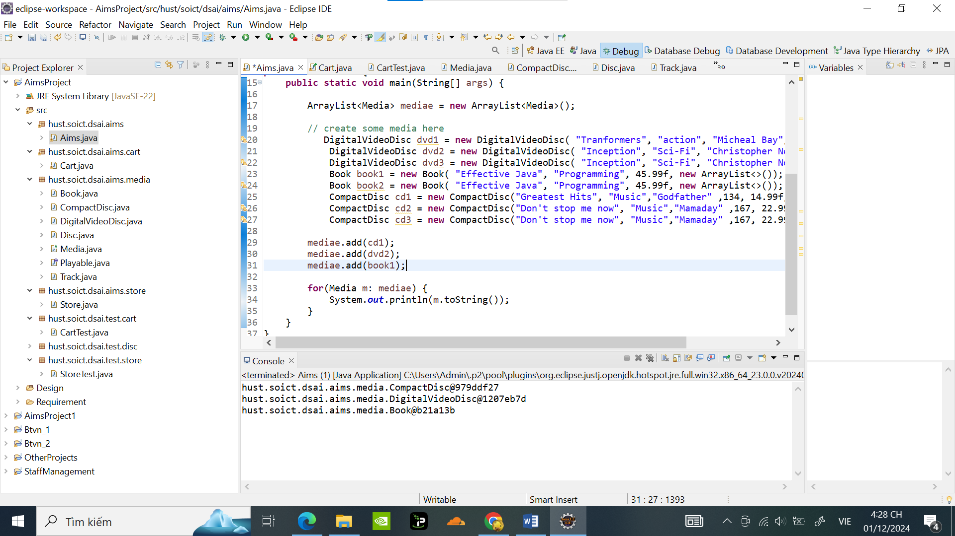

Sau khi Override tại CompactDisc, DigitalVideoDisc, Books,Track;

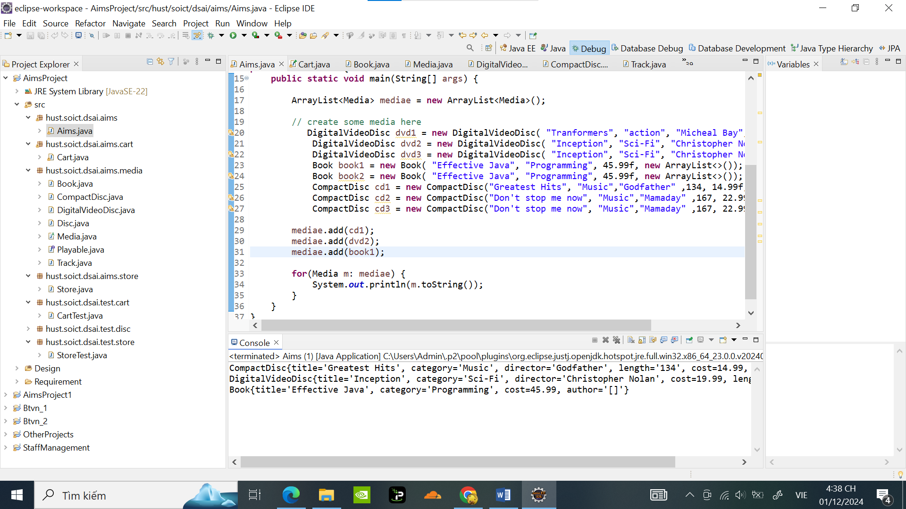

1. **Sort media in the cart**

Tạo Package hust.soict.dsai.aims.comparator

Tạo Class MediaComparatorByCostTitle

**package** hust.soict.dsai.aims.comparator;

**import** java.util.Comparator;

**import** hust.soict.dsai.aims.media.Media;

**public** **class** MediaComparatorByCostTitle **implements** Comparator<Media> {

@Override

**public** **int** compare(Media m1, Media m2) {

**int** costComparison = Float.*compare*(m2.getCost(), m1.getCost()); // Higher cost first

**if** (costComparison == 0) {

**return** m1.getTitle().compareToIgnoreCase(m2.getTitle()); // Alphabetical order

}

**return** costComparison;

}

}

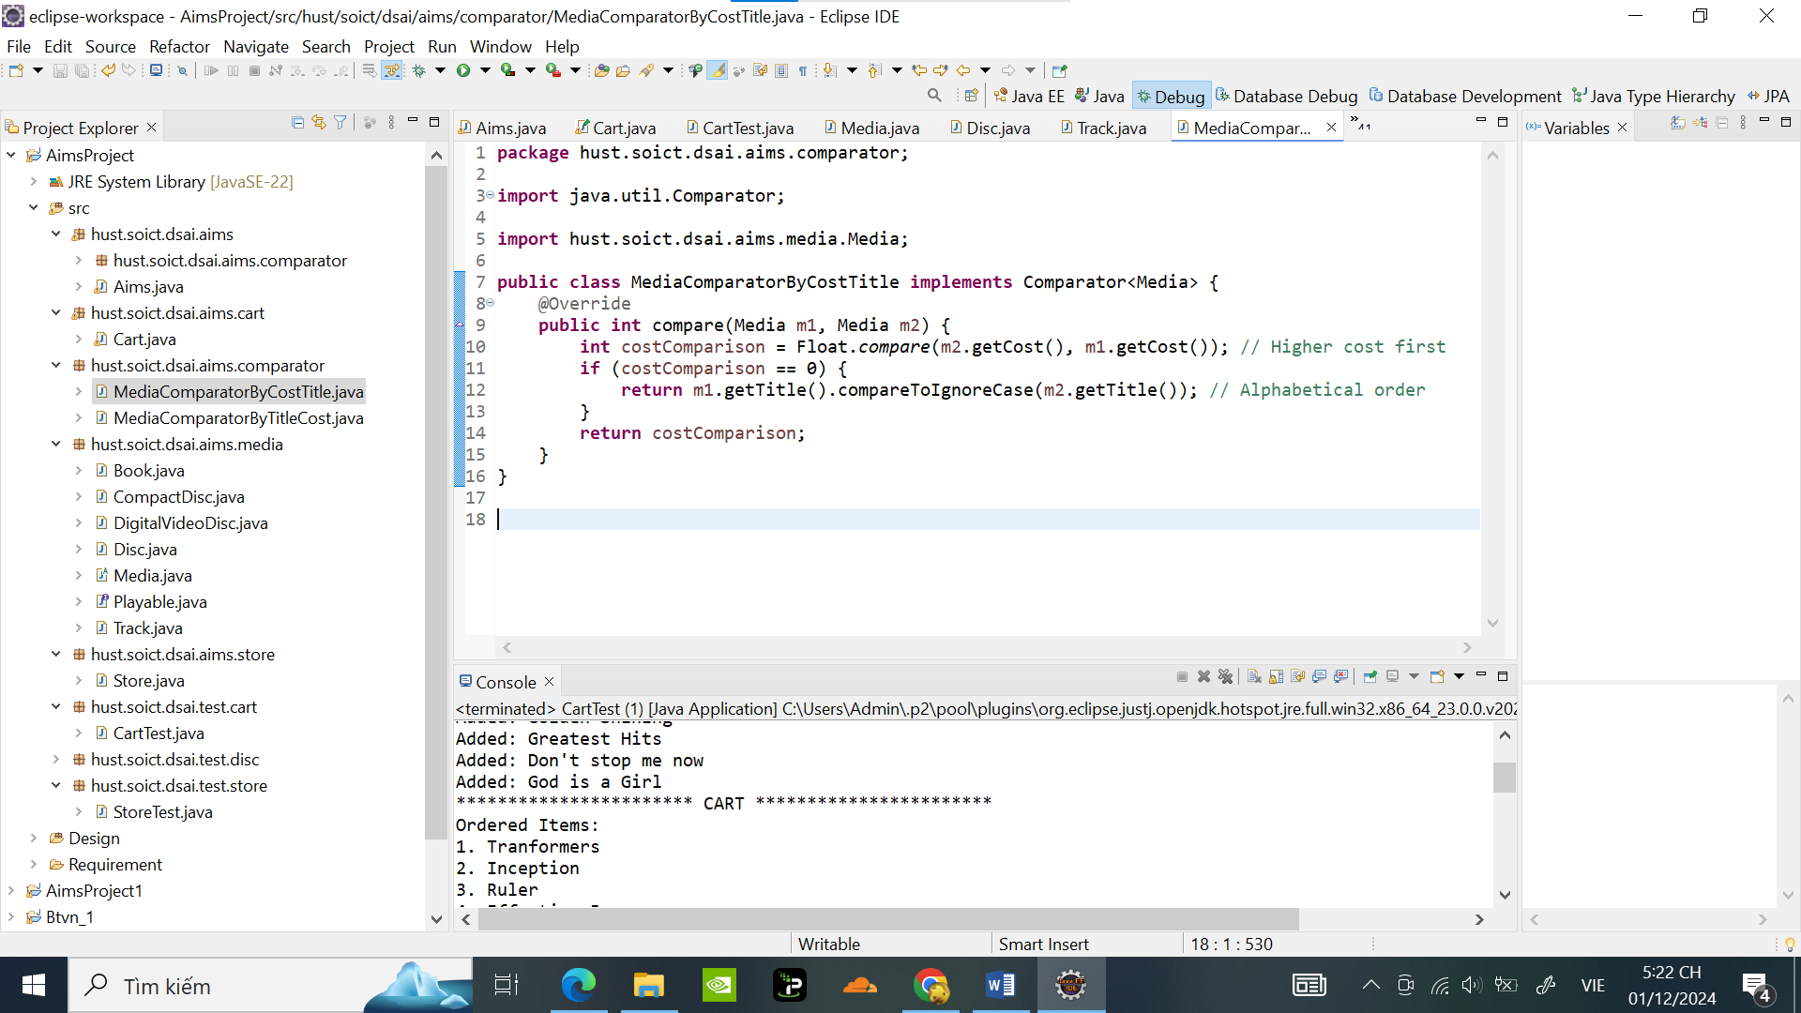

Tạo Class MediaComparatorByTitleCost

**package** hust.soict.dsai.aims.comparator;

**import** java.util.Comparator;

**import** hust.soict.dsai.aims.media.Media;

**public** **class** MediaComparatorByTitleCost **implements** Comparator<Media> {

@Override

**public** **int** compare(Media m1, Media m2) {

**int** titleComparison = m1.getTitle().compareToIgnoreCase(m2.getTitle());

**if** (titleComparison == 0) {

**return** Float.*compare*(m2.getCost(), m1.getCost()); // Higher cost first

}

**return** titleComparison;

}

}

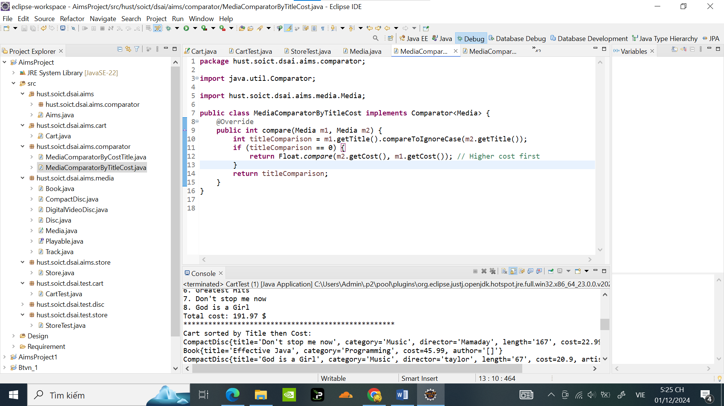

Thêm các câu lệnh Sort vào Media:

**public** **static** **final** Comparator<Media> ***COMPARE_BY_TITLE_COST*** = **new** MediaComparatorByTitleCost();

**public** **static** **final** Comparator<Media> ***COMPARE_BY_COST_TITLE*** = **new** MediaComparatorByCostTitle();

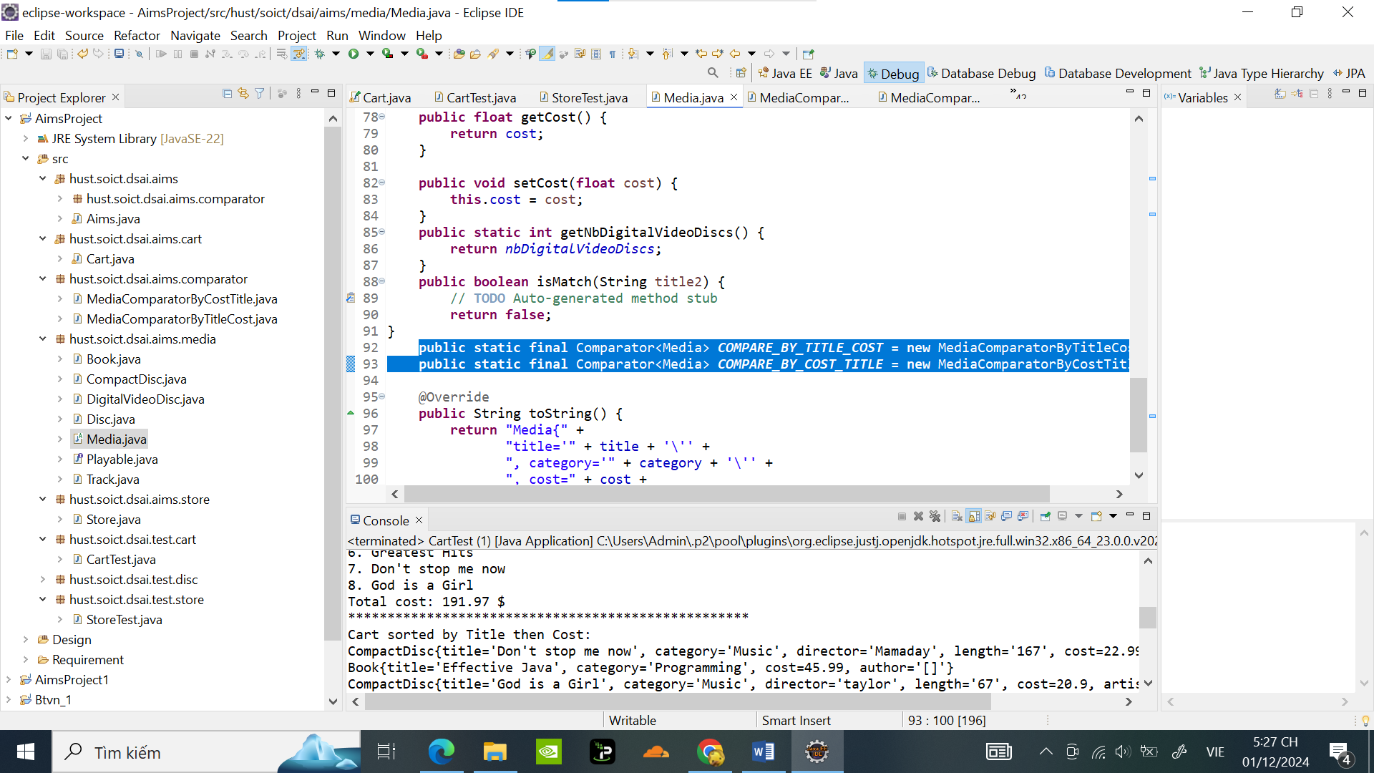

Test thử trong CartTest:

**package** hust.soict.dsai.test.cart;

**import** java.util.ArrayList;

**import** hust.soict.dsai.aims.cart.Cart;

**import** hust.soict.dsai.aims.media.Book;

**import** hust.soict.dsai.aims.media.CompactDisc;

**import** hust.soict.dsai.aims.media.DigitalVideoDisc;

**public** **class** CartTest {

**public** **static** **void** main(String[] args) {

Cart cart = **new** Cart();

// Tạo các đối tượng Media

DigitalVideoDisc dvd1 = **new** DigitalVideoDisc( "Tranformers", "action", "Micheal Bay", 198, 39.99f);

DigitalVideoDisc dvd2 = **new** DigitalVideoDisc( "Inception", "Sci-Fi", "Christopher Nolan", 148, 19.99f);

DigitalVideoDisc dvd3 = **new** DigitalVideoDisc( "Ruler", "anime", "Mihazaki", 121, 11.67f);

Book book1 = **new** Book( "Effective Java", "Programming", 45.99f, **new** ArrayList<>());

Book book2 = **new** Book( "Golden Shining ", "Art ", 15.45f, **new** ArrayList<>());

CompactDisc cd1 = **new** CompactDisc("Greatest Hits", "Music","Godfather" ,134, 14.99f,"J-97");

CompactDisc cd2 = **new** CompactDisc("Don't stop me now", "Music","Mamaday" ,167, 22.99f,"hololive");

CompactDisc cd3 = **new** CompactDisc("God is a Girl", "Music","taylor" ,67, 20.9f,"live");

cart.addMedia(dvd1);

cart.addMedia(dvd2);

cart.addMedia(dvd3);

cart.addMedia(book1);

cart.addMedia(book2);

cart.addMedia(cd1);

cart.addMedia(cd2);

cart.addMedia(cd3);

cart.printCart();

cart.displayCartByTitleCost();

System.***out***.println("\n -------------------------------------\n");

cart.displayCartByCostTitle();

}

}

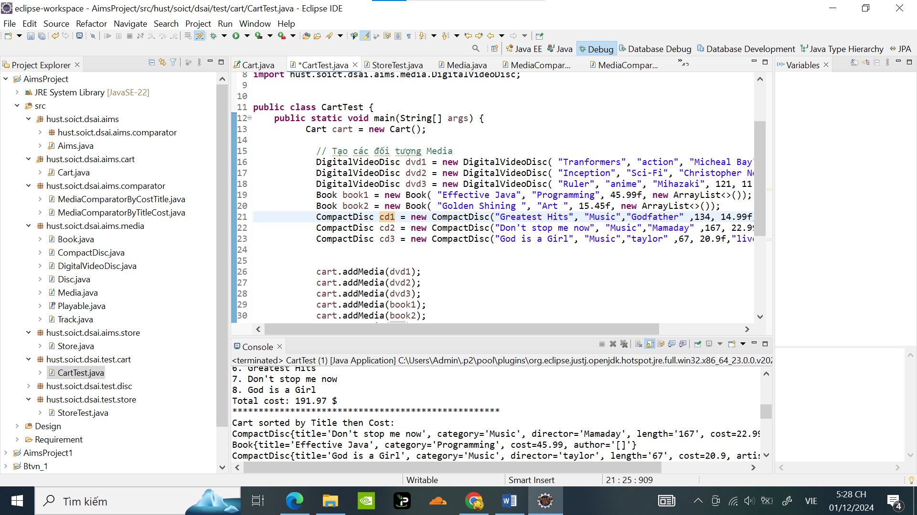

Kết quả :

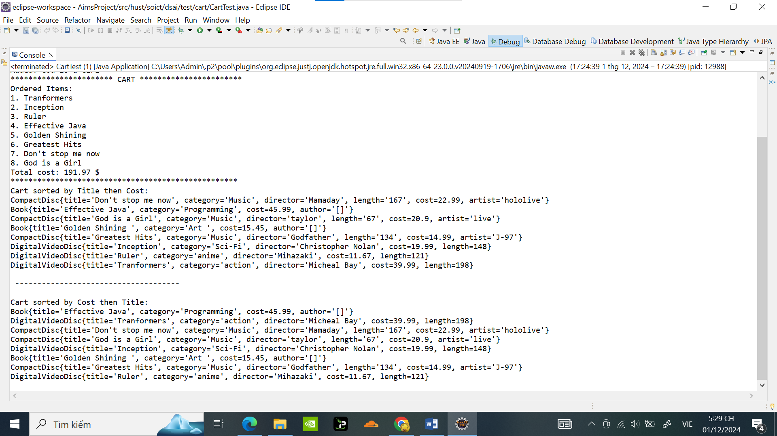

1. **Create a complete console application in the Aims class**

Code trong Aims Class :

**package** hust.soict.dsai.aims;

**import** java.util.ArrayList;

**import** java.util.Locale;

**import** hust.soict.dsai.aims.cart.Cart;

**import** hust.soict.dsai.aims.media.Book;

**import** hust.soict.dsai.aims.media.CompactDisc;

**import** hust.soict.dsai.aims.media.DigitalVideoDisc;

**import** hust.soict.dsai.aims.media.Media;

**import** hust.soict.dsai.aims.media.Playable;

**import** hust.soict.dsai.aims.media.Track;

**import** hust.soict.dsai.aims.store.Store;

**import** java.util.Scanner;

**public** **class** Aims {

**private** **static** **final** Scanner ***scanner*** = **new** Scanner(System.***in***);

**public** **static** **void** main(String[] args) {

Store store = **new** Store();

Cart cart = **new** Cart();

// Example media added to the store

DigitalVideoDisc dvd1 = **new** DigitalVideoDisc( "Inception", "Sci-Fi", "Christopher Nolan", 148, 19.99f);

DigitalVideoDisc dvd2 = **new** DigitalVideoDisc( "Tranformers", "action", "Micheal Bay", 198, 39.99f);

Book book1 = **new** Book( "conan", "anime", 15.99f, **new** ArrayList<>());

Book book2 = **new** Book( "doraemon", "anime", 12.45f, **new** ArrayList<>());

Book book3 = **new** Book( "Effective Java", "Programming", 45.99f, **new** ArrayList<>());

CompactDisc cd1 = **new** CompactDisc("Greatest Hits", "Music","Godfather" ,134, 14.99f,"J-97");

CompactDisc cd2 = **new** CompactDisc("Don't stop me now", "Music","Mamaday" ,167, 22.99f,"hololive");

store.addMedia(dvd1);

store.addMedia(dvd2);

store.addMedia(book1);

store.addMedia(book2);

store.addMedia(book3);

store.addMedia(cd1);

store.addMedia(cd2);

**int** choice;

**do** {

*showMenu*();

choice = ***scanner***.nextInt();

***scanner***.nextLine(); // Clear the newline

**switch** (choice) {

**case** 1:

*viewStore*(store, cart);

**break**;

**case** 2:

*updateStore*(store);

**break**;

**case** 3:

*viewCart*(cart);

**break**;

**case** 0:

System.***out***.println("Exiting AIMS. Goodbye!");

**break**;

**default**:

System.***out***.println("Invalid choice. Please try again.");

}

} **while** (choice != 0);

}

**public** **static** **void** showMenu() {

System.***out***.println("AIMS: ");

System.***out***.println("-------------------------------------");

System.***out***.println("1. View store");

System.***out***.println("2. Update store");

System.***out***.println("3. See current cart");

System.***out***.println("0. Exit");

System.***out***.println("-------------------------------------");

System.***out***.print("Please choose a number: 0-1-2-3: ");

}

**public** **static** **void** storeMenu() {

System.***out***.println("Options: ");

System.***out***.println("-------------------------------------");

System.***out***.println("1. See a media's details");

System.***out***.println("2. Add a media to cart");

System.***out***.println("3. Play a media");

System.***out***.println("4. See current cart");

System.***out***.println("0. Back");

System.***out***.println("-------------------------------------");

System.***out***.print("Please choose a number: 0-1-2-3-4: ");

}

**public** **static** **void** mediaDetailsMenu() {

System.***out***.println("Options: ");

System.***out***.println("--------------------------------");

System.***out***.println("1. Add to cart");

System.***out***.println("2. Play");

System.***out***.println("0. Back");

System.***out***.println("--------------------------------");

System.***out***.print("Please choose a number: 0-1-2: ");

}

**public** **static** **void** cartMenu() {

System.***out***.println("Options: ");

System.***out***.println("--------------------------------");

System.***out***.println("1. Filter medias in cart");

System.***out***.println("2. Sort medias in cart");

System.***out***.println("3. Remove media from cart");

System.***out***.println("4. Play a media");

System.***out***.println("5. Place order");

System.***out***.println("0. Back");

System.***out***.println("--------------------------------");

System.***out***.print("Please choose a number: 0-1-2-3-4-5: ");

}

**private** **static** **void** viewStore(Store store, Cart cart) {

**int** choice;

**do** {

System.***out***.println("\nStore contents:");

System.***out***.println(store);

*storeMenu*();

choice = ***scanner***.nextInt();

***scanner***.nextLine(); // Clear the newline

**switch** (choice) {

**case** 1:

*seeMediaDetails*(store, cart);

**break**;

**case** 2:

*addMediaToCart*(store, cart);

**break**;

**case** 3:

*playMedia*(store);

**break**;

**case** 4:

*viewCart*(cart);

**break**;

**case** 0:

**break**;

**default**:

System.***out***.println("Invalid choice. Please try again.");

}

} **while** (choice != 0);

}

**private** **static** **void** seeMediaDetails(Store store, Cart cart) {

System.***out***.print("Enter the title of the media: ");

String title = ***scanner***.nextLine();

Media media = store.searchByTitle(title);

**if** (media != **null**) {

System.***out***.println(media);

**int** choice;

**do** {

*mediaDetailsMenu*();

choice = ***scanner***.nextInt();

***scanner***.nextLine(); // Clear the newline

**switch** (choice) {

**case** 1:

cart.addMedia(media);

System.***out***.println("Added to cart.");

**break**;

**case** 2:

**if** (media **instanceof** Playable) {

((Playable) media).play();

} **else** {

System.***out***.println("This media cannot be played.");

}

**break**;

**case** 0:

**break**;

**default**:

System.***out***.println("Invalid choice. Please try again.");

}

} **while** (choice != 0);

} **else** {

System.***out***.println("Media not found.");

}

}

**private** **static** **void** addMediaToCart(Store store, Cart cart) {

System.***out***.print("Enter the title of the media to add to cart: ");

String title = ***scanner***.nextLine();

Media media = store.searchByTitle(title);

**if** (media != **null**) {

cart.addMedia(media);

System.***out***.println("Media added to cart.");

} **else** {

System.***out***.println("Media not found.");

}

}

**private** **static** **void** playMedia(Store store) {

System.***out***.print("Enter the title of the media to play: ");

String title = ***scanner***.nextLine();

Media media = store.searchByTitle(title);

**if** (media != **null** && media **instanceof** Playable) {

((Playable) media).play();

} **else** {

System.***out***.println("This media cannot be played or was not found.");

}

}

**private** **static** **void** updateStore(Store store) {

System.***out***.println("1. Add media to store");

System.***out***.println("2. Remove media from store");

System.***out***.print("Choose an option: ");

**int** choice = ***scanner***.nextInt();

***scanner***.nextLine(); // Clear the newline

**if** (choice == 1) {

System.***out***.println("Choose the type of media:");

System.***out***.println("1. Book");

System.***out***.println("2. Digital Video Disc");

System.***out***.println("3. Compact Disc");

System.***out***.print("Enter your choice: ");

**int** mediaType = ***scanner***.nextInt();

***scanner***.nextLine();

**if** (mediaType == 1) {

System.***out***.print("Enter title of new Book: ");

String title = ***scanner***.nextLine();

System.***out***.print("Enter category: ");

String category = ***scanner***.nextLine();

***scanner***.nextLine();

System.***out***.print("Enter cost:");

***scanner***.useLocale(Locale.***US***);

**float** cost = ***scanner***.nextFloat();

System.***out***.print("Enter authors (separated by commas): ");

String authorsInput = ***scanner***.nextLine();

ArrayList<String> authors = **new** ArrayList<>();

// Tách chuỗi thành danh sách các tác giả

**if** (!authorsInput.isEmpty()) {

String[] authorsArray = authorsInput.split(","); // Tách theo dấu phẩy

**for** (String author : authorsArray) {

authors.add(author.trim()); // Xóa khoảng trắng thừa

}

}

***scanner***.nextLine();

Book media =**new** Book(title, category, cost ,authors );

store.addMedia(media);

System.***out***.print("Media added to store.");

} **else** **if** (mediaType ==2 ) {

System.***out***.print("Enter title of new DVD: ");

String title = ***scanner***.nextLine();

System.***out***.print("Enter category: ");

String category = ***scanner***.nextLine();

System.***out***.print("Enter Director: ");

String Director = ***scanner***.nextLine();

System.***out***.print("Enter length: ");

**int** length = ***scanner***.nextInt();

***scanner***.nextLine();

System.***out***.print("Enter cost: ");

***scanner***.useLocale(Locale.***US***);

**float** cost = ***scanner***.nextFloat();

***scanner***.nextLine();

DigitalVideoDisc media = **new** DigitalVideoDisc(title, category, Director, length , cost);

store.addMedia(media);

System.***out***.print("Media added to store.");

} **else** **if**(mediaType == 3) {

System.***out***.print("Enter title of new CD: ");

String title = ***scanner***.nextLine();

System.***out***.print("Enter category: ");

String category = ***scanner***.nextLine();

System.***out***.print("Enter Director: ");

String Director = ***scanner***.nextLine();

System.***out***.print("Enter length: ");

**int** length = ***scanner***.nextInt();

***scanner***.nextLine();

System.***out***.print("Enter cost: ");

***scanner***.useLocale(Locale.***US***);

**float** cost = ***scanner***.nextFloat();

System.***out***.print("Enter artist: ");

String artist = ***scanner***.nextLine();

***scanner***.nextLine();

CompactDisc media = **new** CompactDisc(title, category, Director, length , cost, artist);

store.addMedia(media);

System.***out***.print("Media added to store.");

} **else** {

System.***out***.println("Invalid choice.");

}

} **else** **if** (choice == 2) {

System.***out***.print("Enter title of media to remove: ");

String title = ***scanner***.nextLine();

Media media = store.searchByTitle(title);

**if** (media != **null**) {

store.removeMedia(media);

System.***out***.println("Media removed from store.");

} **else** {

System.***out***.println("Media not found.");

}

} **else** {

System.***out***.println("Invalid choice.");

}

}

**private** **static** **void** viewCart(Cart cart) {

**int** choice;

**do** {

System.***out***.println("\nCurrent cart contents:");

cart.printCart();

*cartMenu*();

choice = ***scanner***.nextInt();

***scanner***.nextLine(); // Clear the newline

**switch** (choice) {

**case** 1:

System.***out***.println("Filter options:");

System.***out***.println("1. Filter by title");

System.***out***.println("2. Filter by id");

System.***out***.println("Choose options:");

**int** choice1 = ***scanner***.nextInt();

***scanner***.nextLine(); // Clear newline

**if** (choice1 ==1) {

System.***out***.print("Enter title to filter by: ");

String titleFilter1 = ***scanner***.nextLine();

cart.filterCartbyTitle(titleFilter1);

**break**;

} **else** **if** (choice1 ==2) {

System.***out***.print("Enter Id to filter by: ");

String IdFilter1 = ***scanner***.nextLine();

cart.filterCartbyId(IdFilter1);

**break**;

} **else** {

System.***out***.println("Invalid choice.");

}

**case** 2:

System.***out***.println("Sort options:");

System.***out***.println("1. Sort by title");

System.***out***.println("2. Sort by Cost");

System.***out***.println("Choose options:");

**int** choice2 = ***scanner***.nextInt();

***scanner***.nextLine(); // Clear newline

**if** (choice2 ==1) {

cart.sortCartbyTitle();

**break**;

} **else** **if** (choice2 ==2) {

cart.sortCartbyCost();

**break**;

} **else** {

System.***out***.println("Invalid choice.");

}

**case** 3:

System.***out***.print("Enter title of media to remove: ");

String title = ***scanner***.nextLine();

cart.removeMediaByTitle(title);

**break**;

**case** 4:

System.***out***.print("Enter title of media to play: ");

String playTitle = ***scanner***.nextLine();

cart.playMedia(playTitle);

**break**;

**case** 5:

System.***out***.println("Order placed! Cart is now empty.");

cart.clear();

**break**;

**case** 0:

**break**;

**default**:

System.***out***.println("Invalid choice. Please try again.");

}

} **while** (choice != 0);

}

}

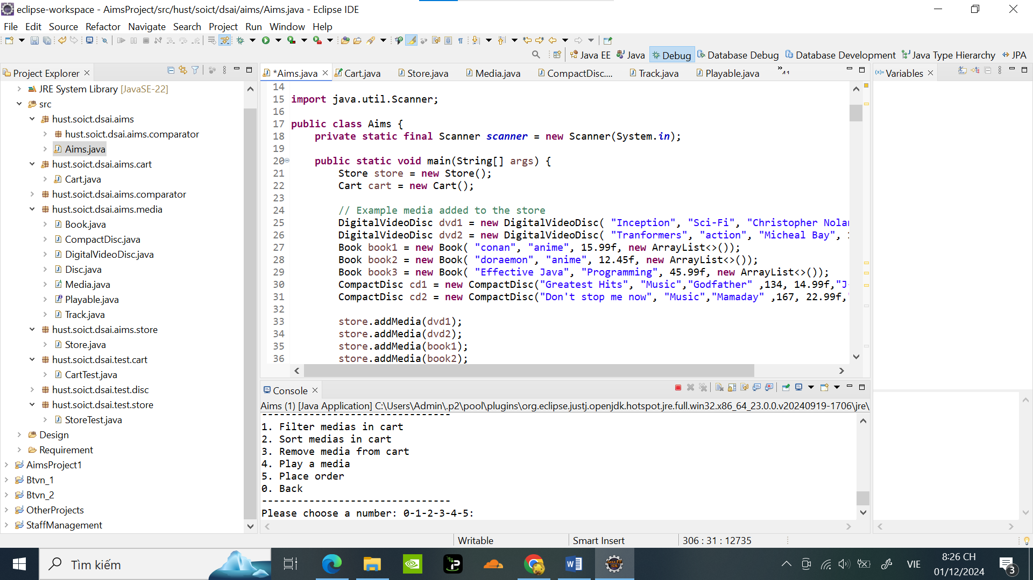

Giao diện của chương trình : 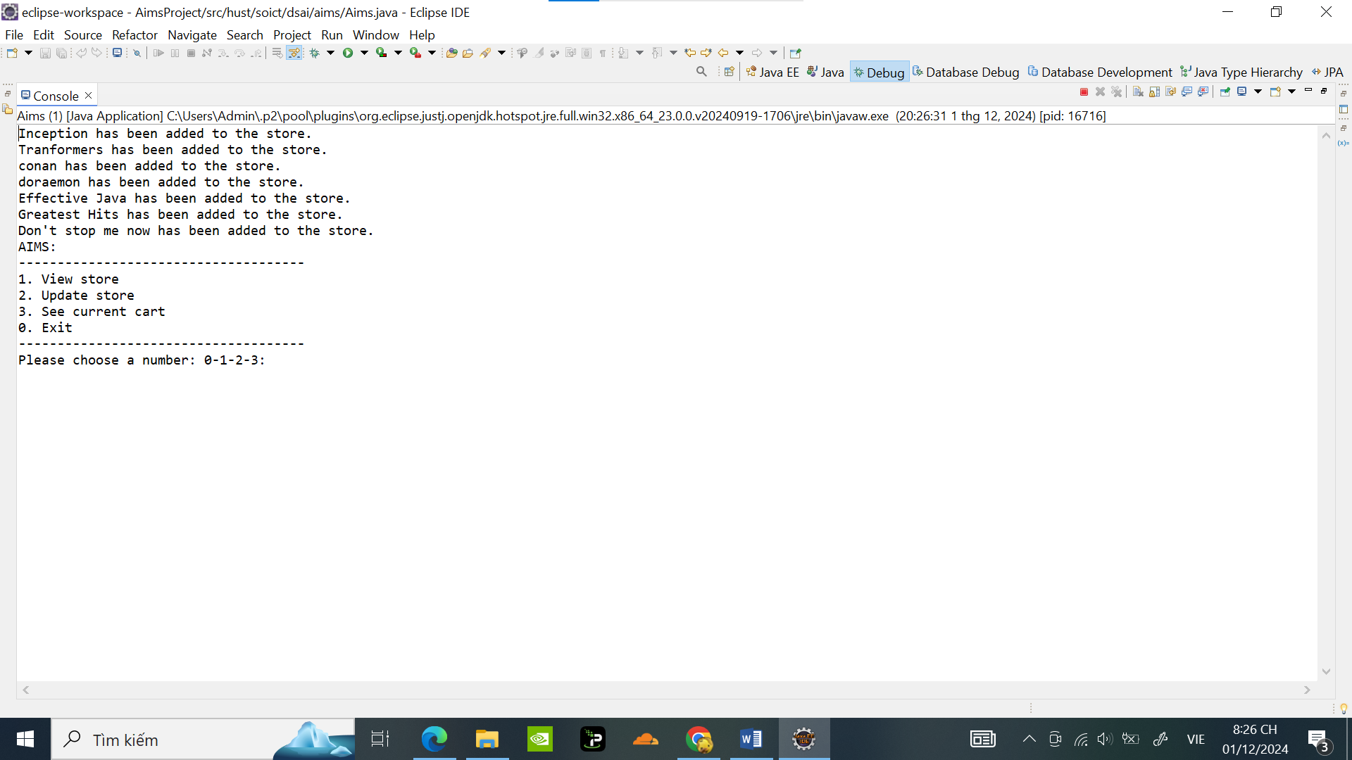

Chọn 1.ViewStore để vào giao diện StoreContents

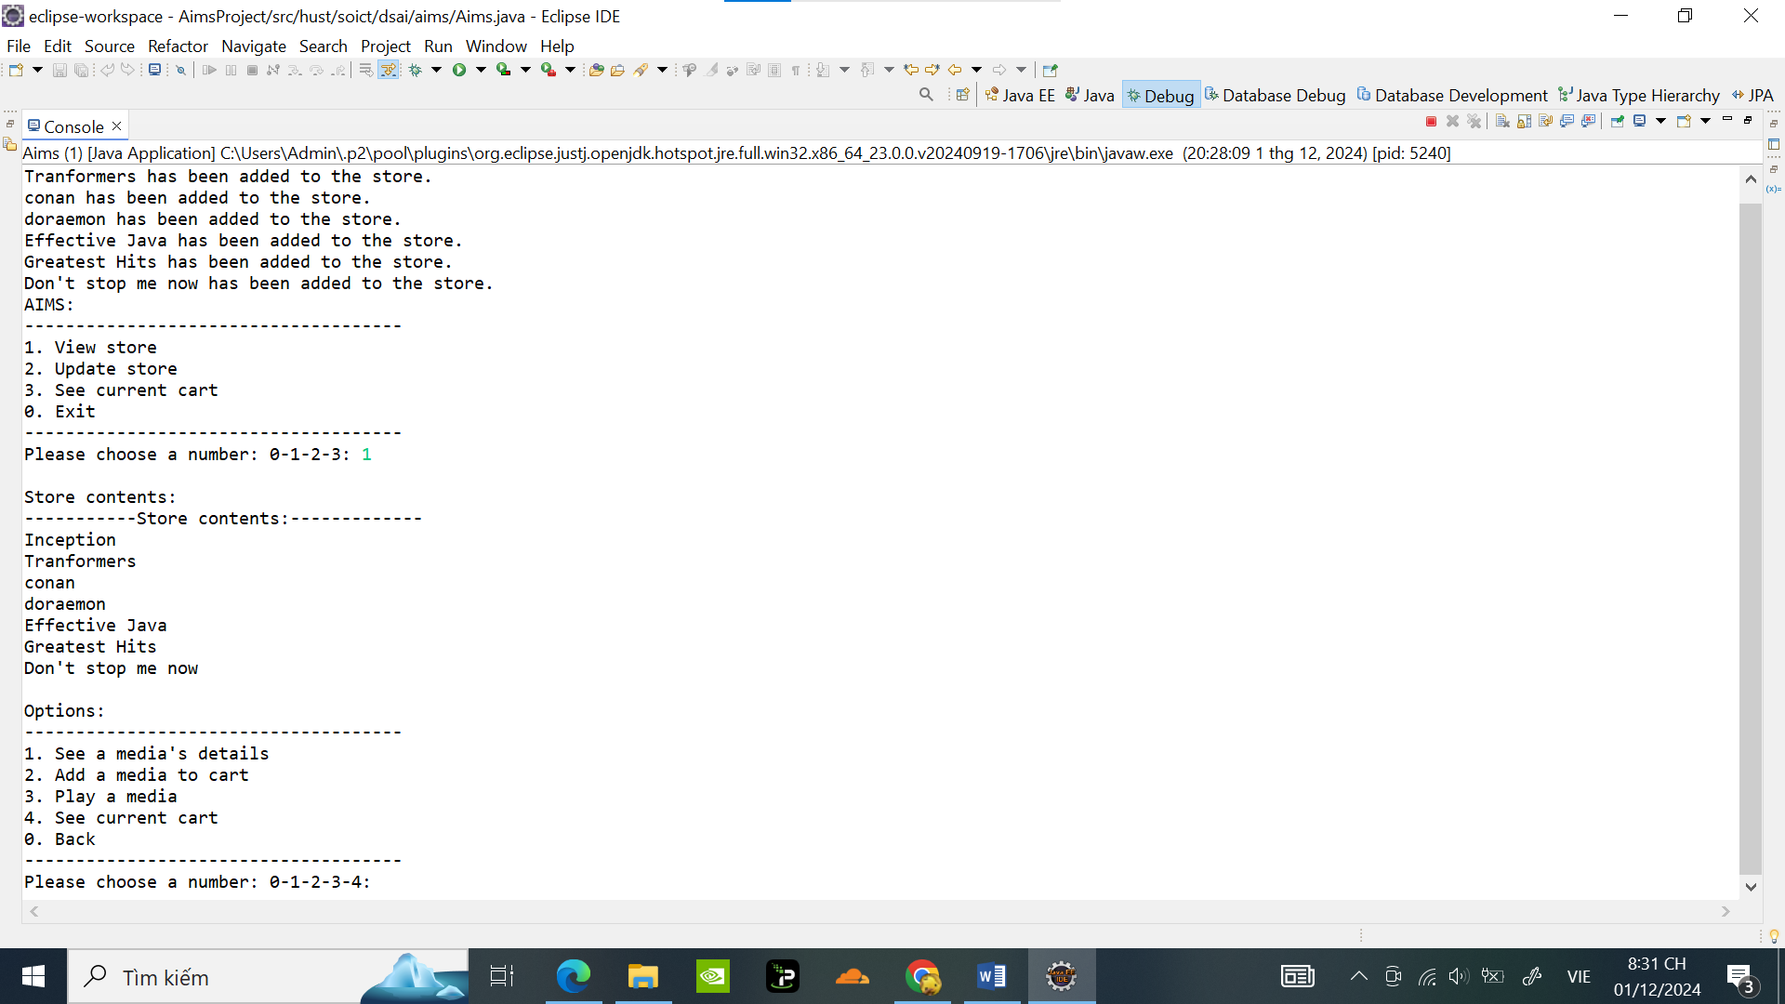

Chọn 1. See a media’s detailts ***Conan***: và chọn add a Cart và play media (có thể chọn bên ngoài qua 2. ; 3. ):

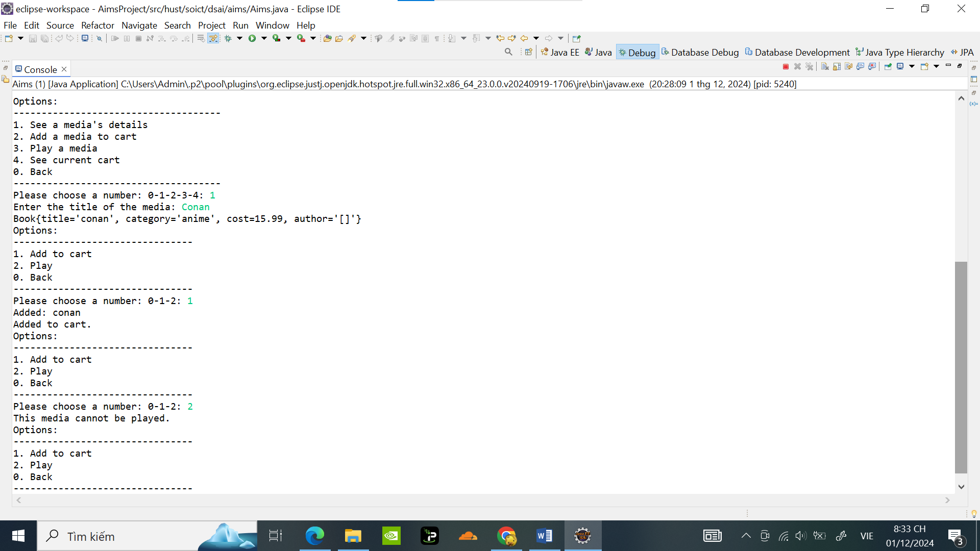

Add media vào Cart và seeCurentCart:

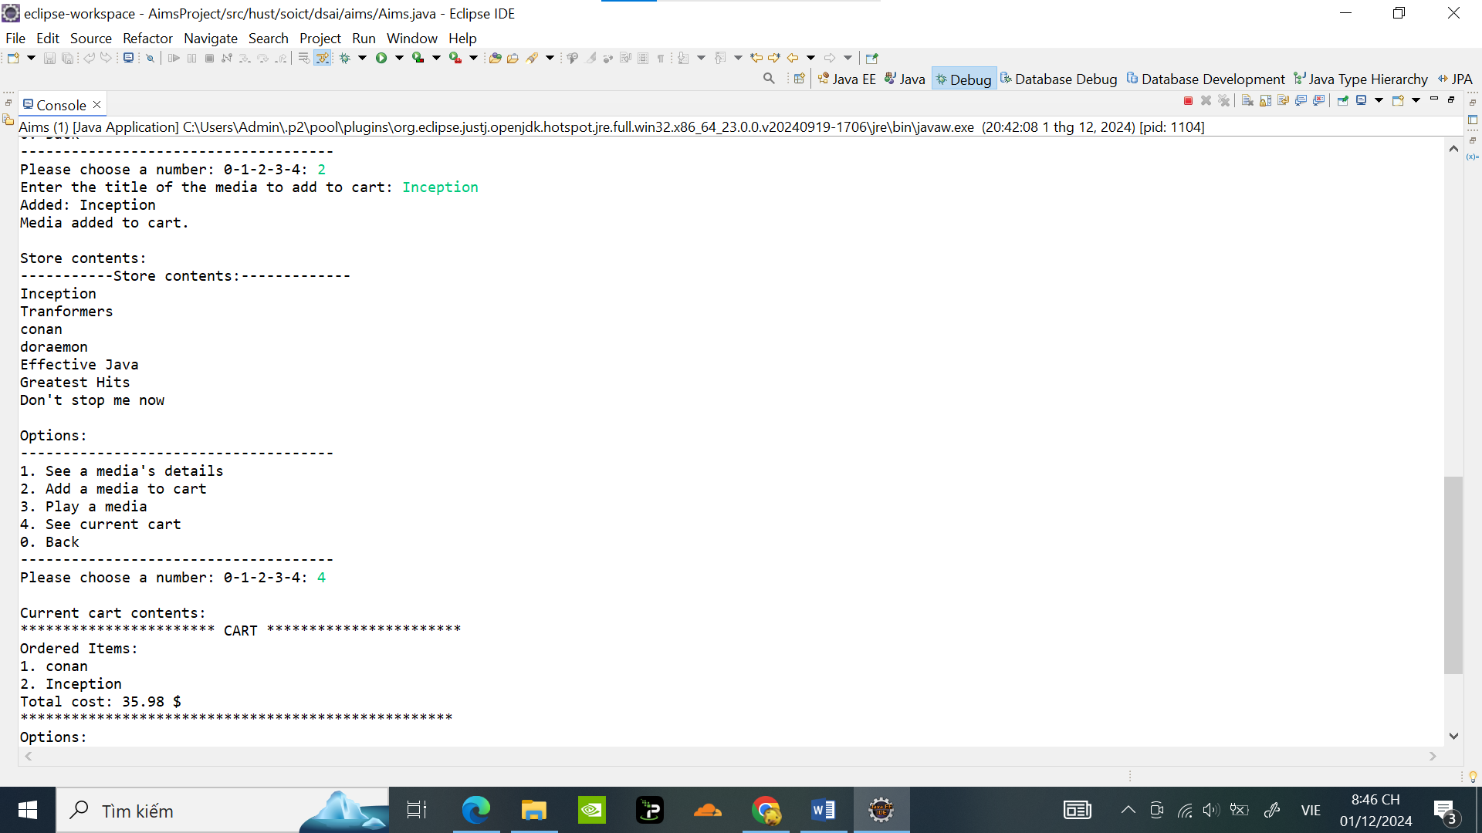

FilterMedia và SortMedia trong giỏ hàng :

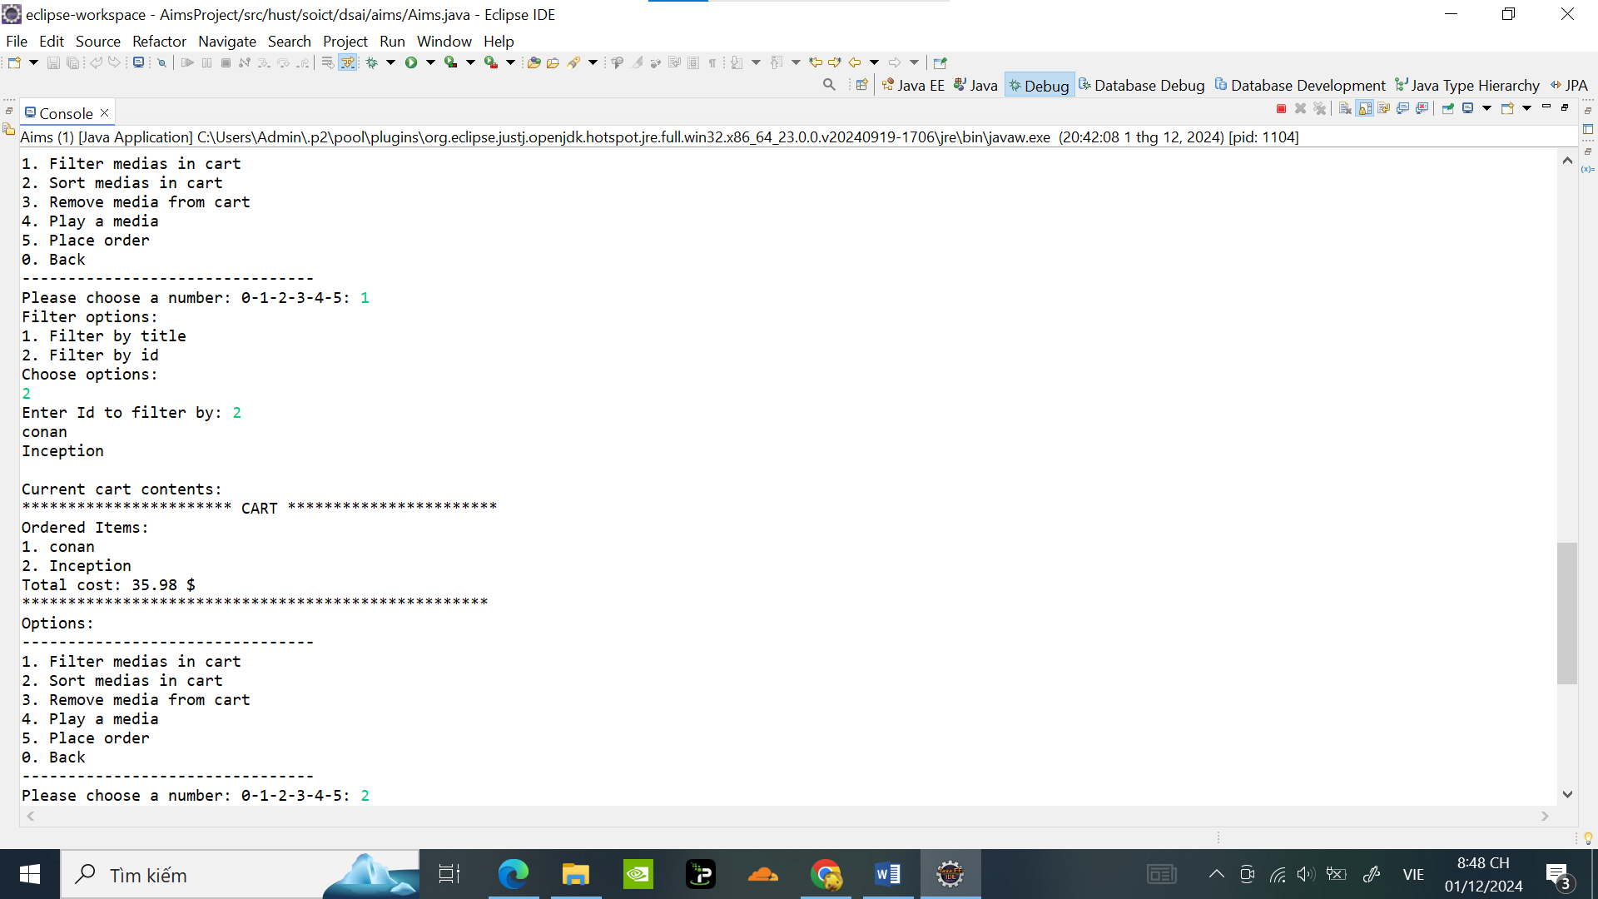

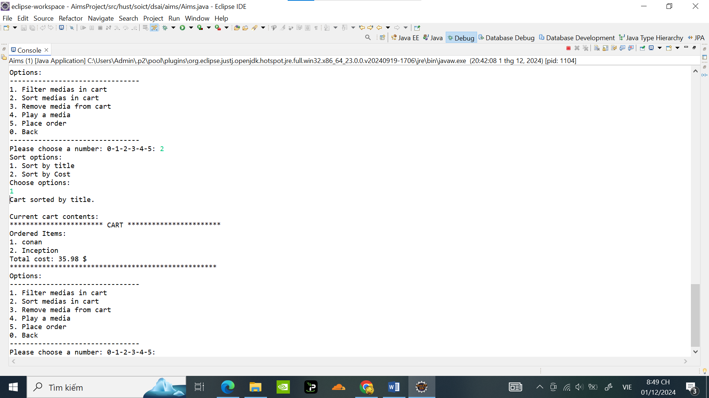

Remove media ***Conan*** trong giỏ hàng :

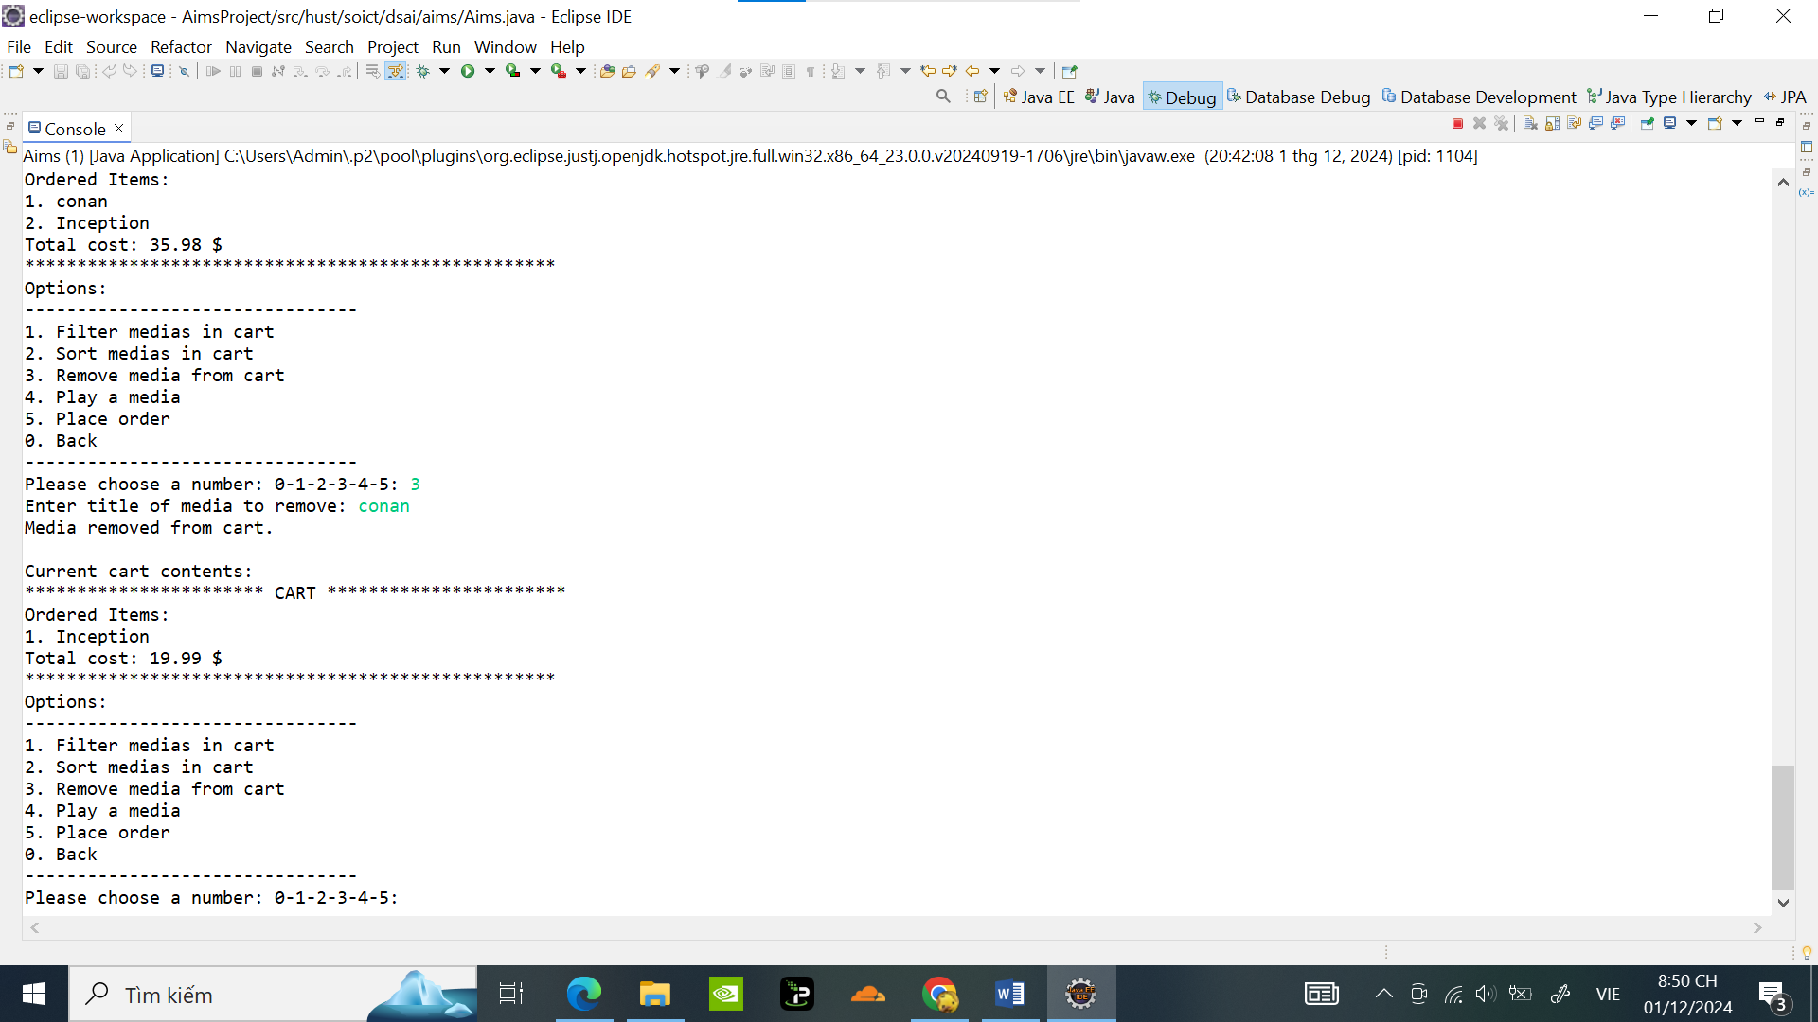

OrderPlace xóa hết đơn hàng trong Ccart vì sẽ dc Order:

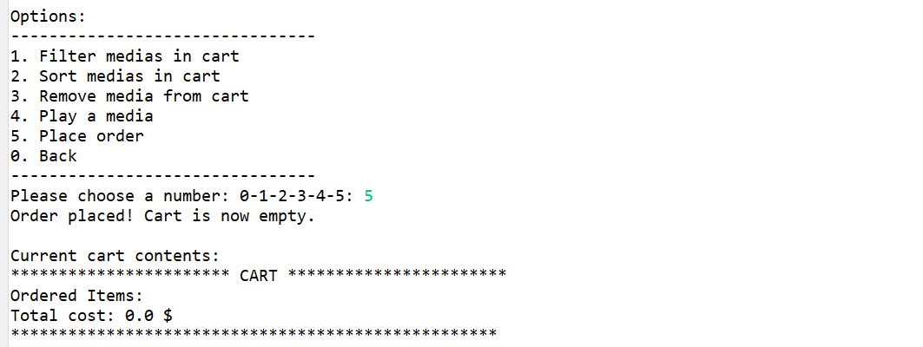

Thêm và xóa Dvd khỏi store:

Thêm đĩa Godzilla với các thuộc tính tương ứng:

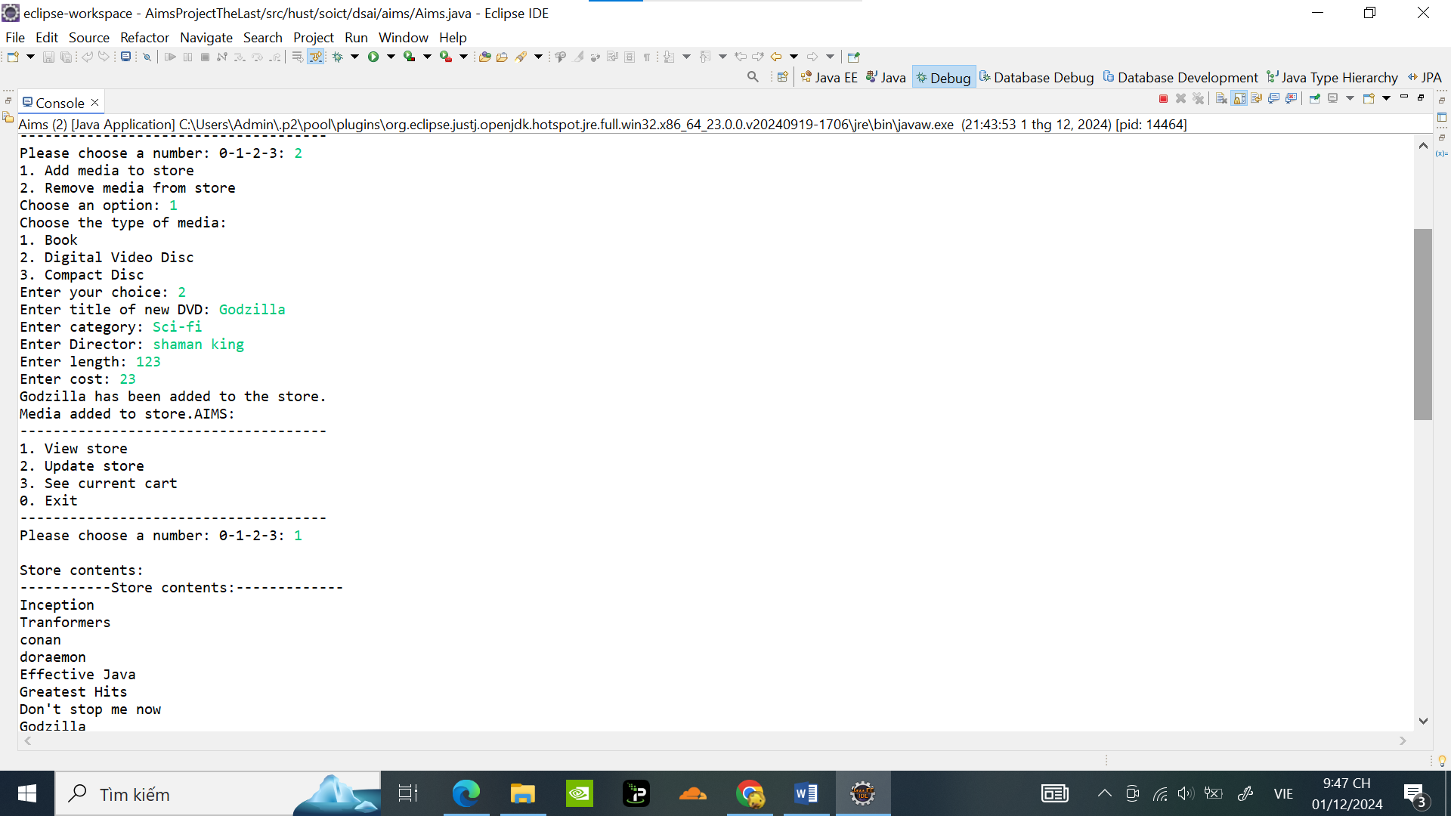

Xóa dvd Godzilla:

